(1) Submission ID#726247
Texture Analysis of Deep Medullary Veins on Susceptibility-Weighted Imaging in Infants: Evaluating Developmental and Ischemic Changes
Submitter: Hyun Gi Kim – Eunpyeong St. Marys Hospital, The Catholic University of Korea
Author(s)
Hyun Gi Kim
Clinical Assistant Professor
Eunpyeong St. Marys Hospital, The Catholic University of Korea

Jin Wook Choi
Ajou University Hospital
Miran Han
Ajou University Hospital
Submission Topic
Brain - Developmental
Abstract
Purpose: Susceptibility-weighted imaging (SWI) can be used to evaluate deep medullary veins (DMVs). This study aimed to apply texture analysis on SWI to evaluate developmental and ischemic changes of DMV in infants.
Methods and Materials: A total of 38 infants with normal brain MRI (preterm [n = 12], term-equivalent age [TEA] [n = 18], and term [n = 8]) and seven infants with ischemic injury (preterm [n = 2], TEA [n = 1], and term [n = 4]) were included. Regions of interests were drawn to include DMVs. Texture parameters including entropy, skewness, and kurtosis were derived from SWI and were compared between groups according to age and presence of ischemic injury. A regression analysis was performed to correlate postmenstrual age (PMA) and parameters and a ROC analysis was performed to differentiate ischemic injured infants from normal infants
Results: Among texture parameters, entropy showed significant difference between the three age groups (preterm vs. TEA vs. term; 5.395 vs. 4.885 vs. 4.883, p = 0.001). There was a significant positive relationship between PMA and entropy (R square = 0.402, p < 0.001). There was a significant negative relationship between PMA and skewness (R square = 0.248, p = 0.001). Skewness was significantly higher in the ischemic group compared to the normal group (1.37 vs. 0.70, p = 0.001). The ROC on skewness resulted in an AUC of 0.87 for differentiating infants with ischemic injury.
Conclusions:A texture analysis of DMVs on SWI showed differences according to age and presence of ischemic injury. The texture parameters can potentially be used as quantitative markers for differentiating infants with ischemic injury through DMV changes

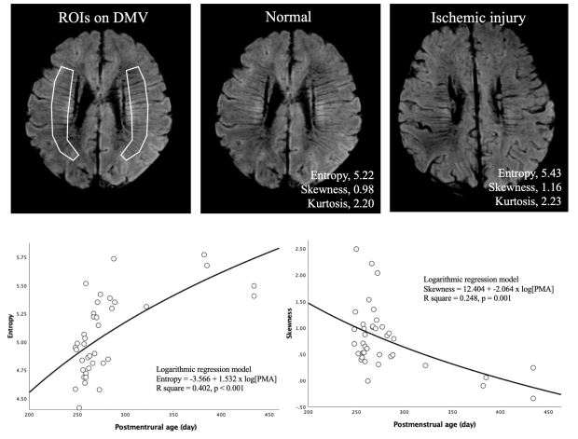

(2) Submission ID#731555
Fetal MRI Findings in Walker-Warburg Phenotype
Submitter: Arian Mashhood – University of California, San Francisco
Author(s)
Arian Mashhood
University of California, San Francisco

Mark Mamlouk
University of California, San Francisco

Camilla Lindan
University of California, San Francisco

Yi Li
University of California, San Francisco

James Barkovich
University of California, San Francisco

Orit A. Glenn
University of California, San Francisco

Submission Topic
Brain - Developmental
Abstract
Purpose:
Identify the fetal MRI findings of Walker-Warburg phenotype, compared to sonographic, postnatal, pathologic and genetic findings.
Methods and Materials:
Electronic medical records were reviewed at two institutions to identify seven subjects with suspected Walker-Warburg phenotype on fetal brain MRI. Fetal brain MRI examinations were reviewed by six neuroradiologists. Sonographic, postnatal, and autopsy results were reviewed, when available.
Results:
Gestational age at MRI ranged from 19 to 23 weeks. Six subjects were scanned on 1.5T, one subject was scanned on 3T. Fetal MRI demonstrated hydrocephalus, dysplastic and small vermis, kinked brainstem, elongated midbrain, thickened tectum, and thinned pons in all seven . Ophthalmologic abnormalities were identified prenatally in two subjects, and postnatally in a third. Cobblestone lissencephaly was suggested in one subject, the only subject scanned at 3T. Another subject exhibited both cleft palate and callosal agenesis. The corpus callosum was at least partially visualized in the remainder of subjects, although due to the severity of hydrocephalus and image resolution, was difficult to fully evaluate. One subject demonstrated an occipital cephalocele.
Sonographic imaging and the reports were reviewed in all seven subjects and all showed ventriculomegaly and/or brainstem or cerebellar abnormalities, but the Walker-Warburg phenotype was not suggested prospectively.
Postnatal imaging was available in one subject and confirmed the fetal MRI findings, and demonstrated cobblestone lissencephaly and irregularity of inner cortical margin. Elevated creatine kinase and history of two siblings with Walker Warburg phenotype were supportive although limited molecular testing was equivocal.
Fetal autopsy was performed on three subjects, and a diagnosis of Walker-Warburg phenotype was confirmed and revealed a POMT1 in one subject and an ISPD mutation in another.
Conclusions:
Fetal MRI can reliably detect characteristic features of the Walker-Warburg phenotype, although is limited in detection of cobblestone lissencephaly. 3T MRI may allow prenatal detection of cobblestone lissencephaly, although additional experience is needed.
References:
Barkovich AJ. Neuroimaging manifestations and classification of congenital muscular dystrophies. American Journal of Neuroradiology September 1998, 19 (8) 1389-1396.
Bahi-Buisson N, et al. GPR56-related bilateral frontoparietal polymicrogyria: further evidence for an overlap with the cobblestone complex. Brain. 2010 Nov;133(11):3194-209. doi: 10.1093/brain/awq259. Epub 2010 Oct 7.
Vajsar J, Schachter H. Walker-Warburg syndrome. Orphanet J Rare Dis. 2006 Aug 3;1:29.

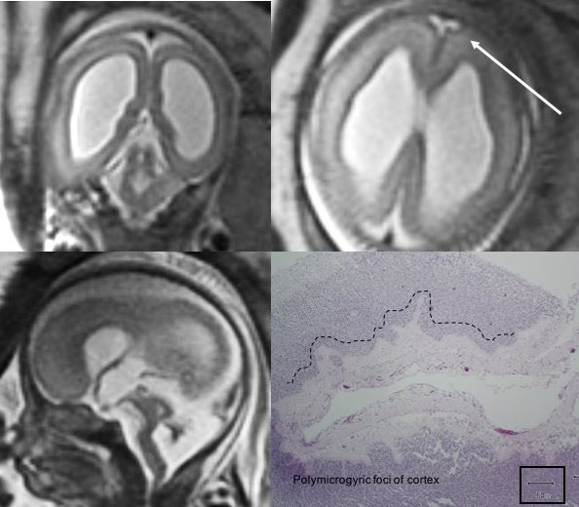

(3) Submission ID#741898
Bilateral Frontal Lobe Polymicrogyria Associated with ACTA-2 Mutation
Submitter: Subramanian Subramanian – UPMC CHildren's Hospital of Pittsburgh
Author(s)
Sophie Darwiche
UPMC

Subramanian Subramanian, MD
Assistant Professor
UPMC CHildren's Hospital of Pittsburgh

Stephanie Greene
Associate Professor
UPMC Children's Hospital of Pittsburgh

Dana Cummings
Associate Professor
UPMC Children's Hospital of Pittsburgh

Ashok Panigrahy
Professor and Vice Chair
UPMC Children's Hospital of pittsburgh
Submission Topic
Brain - Cerebrovascular
Abstract
Objectives: We report unusual association of bilateral frontal lobe polymicrogyria in a patient with ACTA2 mutation.
Learning points: A two-month-old female infant presented with anisocoria and cataract in left eye. An ophthalmologic exam demonstrated left anterior polar cataract, persistent pupillary membrane and tortuosity of retinal artery and cortical lenticular opacity. Based on ophthalmologic evaluation the patient underwent genetic testing for smooth muscle disorder which demonstrated ACTA2 gene: pathogenic variant c.C535.C >T, Arg179Cys known to cause syndrome of multisystem smooth muscle dysfunction. The patient also had intestinal malrotation for which she underwent ladds procedure, bladder diverticulum status post excision, ASD closure and PDA ligation and aortic patch repair and mild dilatation of ascending aorta and arch of aorta. The patient was evaluated by neurology service as ACTA2 mutation can be associated with cerebral vasculopathy and stoke and MRI and MR angiogram were requested. The patient had characteristic MR angiogram findings namely straight course of intracranial arteries, dilated right petrous and lacerum ICA, narrowing of cavernous segment of left ICA, occlusion of supraclinoid left MCA with reformation of left A2 segment from right A1 segment without moya moya collaterals. There was worsening multifocal narrowing of left ACA A2 segment and left M2 and M3 segments with decreased perfusion in left frontal lobe MRI also demonstrated hypoplasia of anterior corpus callosum, radial inferior frontal gyral pattern and dysmorphic midbrain and pons. In addition, patient had bilateral frontal lobe polymicrogyria. The patient underwent left pial synangiosis.
Discussion: Neuroimaging imaging findings in ACTA2 mutation has been described in literature and MR angiogram findings are straight course of intracranial arteries and stretched broomstick appearance of vessels with occlusion of terminal ICA without Moya Moya collaterals. In a recent review of 13 patients DArco F et al have identified hypoplasia of anterior corpus callosum, absent anterior cingulate gyrus and radial orientation of frontal gyration which were demonstrated on present patient. They also described flattening of pons and squeezed cerebral peduncle. However, none of patients in their series demonstrated polymicrogyria. We hypothesize that polymicrogyria may result due to in-utero vasculopathy and injury to pial limiting membrane leading to polymicrogyria. The present patient was asymptomatic for polymicrogyria and did not have seizures.
References: DArco F, Alves CA, Raybaud C, Chong WKK, Ishak GE, Ramji S et al. Expanding the distinctive neuroimaging phenotype of ACTA2 mutations. AJNR Am J Neuroradiol 2018 39(11):2126-2131.
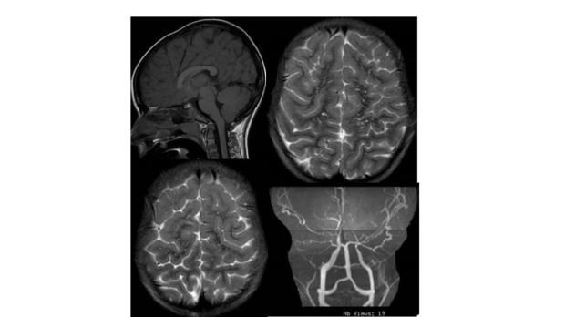

(4) Submission ID#742020
Morphologic Changes of the Dorsal Contour of the Corpus Callosum During the First Two Years of Life
Submitter: Erika Schneble – OHSU
Author(s)
Erika J. Schneble
Resident Physician
OHSU

Lauren N. Simpson, MD MPH
Oregon Health & Science University

Elena Griffin
OHSU

James Obayashi
Oregon Health & Science University

Phillip Setran
OHSU
Donald Ross
Oregon Health an Sciences University
David R. Pettersson, MD
Assistant Professor, Neuroradiology
Oregon Health & Science University

Jeffrey M. Pollock
Associate Professor
OHSU
Submission Topic
Brain - Developmental
- The contents of this abstract has not been accepted for publication or at another meeting.
Abstract
PURPOSE: Our purpose was to characterize the dorsal contour of the corpus callosum during the first 2 years of life by defining the prevalence, onset, and trajectory of notching on midsagittal T1 images.
METHODS AND MATERIALS: 1,157 consecutive patients between birth and 2 years of age were reviewed retrospectively. Corpus callosum morphology was evaluated and described. A "notch" was defined as a dorsal concavity of at least 1 mm in depth along the dorsal surface of the corpus callosum. Patient age as well as notch depth, location, number, and presence of the pericallosal artery in the notch were noted.
RESULTS: A total of 233 notches were identified in 549 patients: 36 anterior, 194 posterior, and 3 patients with undulations. A statistically significant (R2= .532, Beta = 0.021, p = 0.002) positive correlation between posterior notch prevalence and age in months was noted.A positive correlation between age and depth of the posterior notch was also statistically significant (r=0.318, n=179, p 0.001). A trend for increased anterior notch prevalence with age was identified with significant correlation between pericallosal artery presence and anterior notching (r = 0.204, n = 138, p = 0.016). Sub-analysis of the first month of life showed corpus callosum notching was not present in the first week of life.
CONCLUSIONS: The presence of posterior notching increased significantly with age and was more frequent than that of anterior notching. Corpus callosum notching was absent in the first week of life, building on prior studies suggesting that corpus callosum notching is acquired. This study provides baseline data on normative corpus callosum notching trajectories by age group during early life, a helpful correlate when associating corpus callosum morphology with disease.

(5) Submission ID#749240
Prenatal Diagnosis of Third/Fourth Branchial Sinus
Submitter: Arian Mashhood – University of California, San Francisco
Author(s)
Arian Mashhood
University of California, San Francisco

Yi Li
University of California, San Francisco

Mark Mamlouk
University of California, San Francisco

Vickie A. Feldstein
University of California, San Francisco

Orit A. Glenn
University of California, San Francisco

Submission Topic
Head and Neck
Abstract
Purpose:
Illustrate prenatal MRI findings of third/fourth branchial sinuses and correlate with prenatal ultrasound exams, postnatal MRI, and pathologic findings.
Methods and Materials:
Electronic medical records were reviewed for all subjects with fetal neck MRIs with third/fourth branchial sinuses. Prenatal ultrasound, postnatal imaging, and surgical pathologic findings were evaluated.
Results:
Four subjects were identified with third/fourth branchial sinuses detected in utero. Gestational age at diagnosis: 18-21 weeks. In all subjects, the lesions were left-sided, off-midline and unilocular on both prenatal US and MRI.
Sonographically, the lesions were oblong thin-walled nonvascular fluid collections left of midline without significant mass effect. One lesion fluctuated in size with fetal breathing motion indicating communication with the hypopharyngeal airway.
On MRI, they were homogeneously T2 hyperintense, T1 hypointense, with increased diffusivity when DWI was performed. All lesions were tubular and had a component which beaked medially, extending between the spine and airway, contacting the thyroid gland and displacing the cervical vessels posterolaterally. There was variable displacement of the airway. Two lesions crossed the midline posterior to the trachea. No evidence of internal hemorrhage was observed.
In all four subjects, the diagnosis of third/fourth branchial sinus was suggested prenatally.
Postnatal MR imaging showed increase in size in all four cases. In one, growth of the lesion resulted in new extension beyond the midline. One subject received contrast, demonstrating thin peripheral enhancement and communication with the airway. All four contained air within the lesion, indicating communication with the airway.
At surgery, communication with the piriform sinus was documented in three cases. At pathology, the lesions predominantly contained stratified squamous or ciliated columnar epithelium with fibrous components. Two specimens contained scant thyroid tissue.
Conclusions:
Fetal MRI findings of left-sided unilocular cystic lesions in the fetal neck with medial beaking toward the hypopharynx suggest the diagnosis of third/fourth branchial sinuses.
References:
Thomas B, Shroff M, Forte V, Blaser S, James A. Revisiting imaging features and the embryologic basis of third and fourth branchial anomalies. AJNR Am J Neuroradiol. 2010 Apr;31(4):755-60. doi: 10.3174/ajnr.A1902. Epub 2009 Dec 10.
Mandell DL. Head and neck anomalies related to the branchial apparatus. Otolaryngol Clin North Am. 2000 Dec;33(6):1309-32.
Ozolek JA. Selective pathologies of the head and neck in children: a developmental perspective. Adv Anat Pathol. 2009 Sep;16(5):332-58. doi: 10.1097/PAP.0b013e3181b50571.

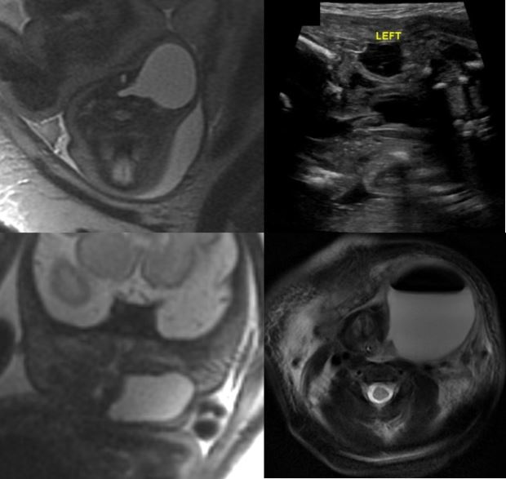

(6) Submission ID#753303
Mri Imaging for Evaluating Tumefactive Virchow-robinson Pathologies
Submitter: bhavini gupta – DY Patil University School of Medicine
Author(s)
bhavini gupta
Resident
DY Patil University School of Medicine

OM TAVRI
DY PATIL UNIVERSITY SCHOOL OF MEDICINE

Submission Topic
Brain - Cerebrovascular
Abstract
INTRODUCTION:
Virchow robin spaces represent perivascular spaces i.e. spaces around arteries, arterioles, veins and venules, and correspond to extensions of subarachnoid space. These spaces are predominantly filled with interstitial fluid and follow CSF intensity. Enlarged perivascular spaces (EPVS) are found increasingly in older population and have been associated with impaired cognitive function, depression, and diabetic retinopathy and are found in and around active lesions associated with inflammation in multiple sclerosis.⁶ While, EPVS is common, it is generally overlooked and of uncertain pathophysiology. EPVS are visible on axial T2-weighted cerebral MRI as characteristic small high-signal areas in the basal ganglia and centrum semiovale that follow the orientation of penetrating arterioles.

AIMS AND OBJECTIVES:
To evaluate and characterize different pathologies associated with enlarged / prominent Virchow robin spaces.
To demonstrate the usual presentations of pathologies that present with prominent VR spaces.

METHODS:
This study was conducted in the Department of Radiology, D.Y. Patil School of Medicine, Nerul, Navi Mumbai, over a period of 1 year.
All neurology cases presenting with prominent VR spaces were studies retrospectively. The main modality used for the entire study was MRI for imaging of the brain. Cases were then followed up, to confirm the diagnosis through various biochemical, genetic and clinical examination.
GE MRI 1.5 Tesla were used for the scans. Axial T2W images were used for the evaluation of prominent VR spaces. More than 2 mm was considered pathological.

RESULTS:
The pathologies found include:
- Hypomelanosis of Ito
- Grade IV periventricular leukomalacia
- Morquio syndrome

CONCLUSION:
While normal VR spaces are encountered frequently, especially in older individuals, pathologically enlarged VR spaces are a rare finding. These may often be mistaken for ominous pathologies. Most of these pathologies result in severe neurological deficits. In fact, prominent perivascular spaces are associated with impaired cognitive functions. Giant tumefactive perivascular spaces are usually seen causing significant mass effect.
Adequate clinical, laboratory and genetic tests are required to confirm the findings. Apart from cross sectional imaging, examination of the patient, can often play important roles in the final diagnosis.

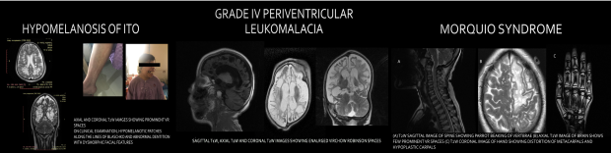

(7) Submission ID#753466
Head and Neck Imaging Findings in Children with PTEN Hamartoma Tumor Syndrome (PHTS)
Submitter: HAIFA ALSARHANI – cheo
Author(s)
Haifa Alsarhani
Pediatric Radiology Fellow
Medical Imaging Department, CHEO, University of Ottawa

Scott Somerville
Assistant Professor and Pediatric Endocrinologist
Division of Endocrinology and Metabolism, CHEO,University of Ottawa

Alexandra Ahmet
Assistant Professor and Pediatric Endocrinologist
Division of Endocrinology and Metabolism, CHEO,University of Ottawa

Sarah Sawyer
Assistant Professor and Clinical Geneticist
Department of Genetics, CHEO, University of Ottawa

Eva Tomiak
Assistant Professor and Clinical Geneticist
Department of Genetics, CHEO, University of Ottawa

Jorge Davila
Pediatric Radiologist
Medical Imaging Department, CHEO, University of Ottawa

Claudia Martinez-Rios
Pediatric Radiologist and Neuropediatric Radiologist
Medical Imaging Department, CHEO, University of Ottawa

Submission Topic
Head and Neck
Abstract
Purpose: PTEN hamartoma tumor syndrome (PHTS) is a cancer predisposition syndrome caused by mutations in the PTEN tumor suppressor gene. PTEN mutations are associated with an increased risk of benign and malignant tumors. Patients typically present with significant macrocephaly. White matter changes are also commonly described. In the neck, patients may present with thyroid gland abnormalities. The purpose of this study is to summarize the spectrum of head and neck imaging characteristics in a cohort of 16 children with PTHS in relationship to their age, and to determine if patients with anomalies in one anatomic location are more likely to have abnormalities in another location.
Materials and Methods: This retrospective REB-approved study evaluated the head and neck imaging findings of children 18 years seen at a pediatric tertiary care center between January 2000 and September 2019, with confirmed molecular diagnosis of PHTS.
Results: 16 patients [(12 male, 4 female); mean age at presentation: 10.4 years, range: birth to 15 years)]. Head and neck imaging encompassed: MRI head (n = 33), MRI neck (n = 1) and neck US (n = 57). MRI findings included: macrocephaly (n = 16); enlarged perivascular spaces (n = 5); multifocal and periventricular white matter abnormalities (n = 8), and one arachnoid cyst. White matter changes remained stable over time. Head MRI findings were detected in a wide range of age between 4 and 156 months. Eight patients had thyroid gland abnormalities detected on US, including: colloid cysts (n = 4), multi-nodular gland (n = 4), one solid TI-RADS 4 nodule (currently on US surveillance) and one thyroglossal duct cyst. Pathology from thyroidectomies in three patients demonstrated: a) non-invasive follicular thyroid cancer; b) moderate chronic lymphocytic thyroiditis with oncocytic metaplasia and nodular thyroid hyperplasia; and c) nodular thyroid hyperplasia with areas of Hurthle cell (oncocytic) metaplasia. One fine needle aspiration confirmed multinodular goiter. Although some patients with white matter changes also had thyroid findings, there was no clear association between radiological findings in one anatomic region compared to another. No other neck abnormalities were identified.
Conclusion: We describe the head and neck imaging phenotype encountered in a series of patients with molecular features consistent with PTEN hamartoma tumor syndrome. Macrocephaly and white matter lesions are common findings, followed by thyroid gland abnormalities, including thyroid carcinoma. Familiarization with the imaging findings in this syndrome is advised, to promptly identify lesions that warrant close observation or further management.

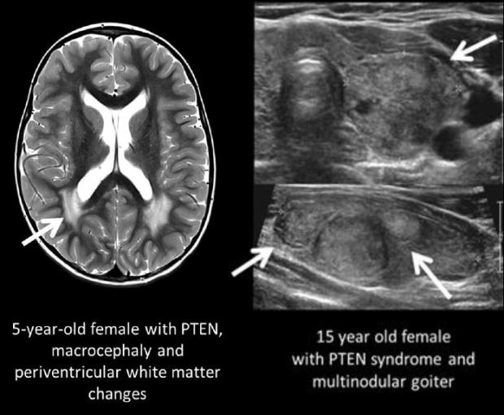

(8) Submission ID#753544
Detection and Natural Progression of Early Childhood Cerebral X-linked Adrenoleukodystrophy
Submitter: Zachary Miller – University of Minnesota Medical School
Author(s)
Zachary D. Miller
Medical Student
University of Minnesota Medical School

Alexis Swenson, MD
University of Minnesota Medical School

David Nascene, MD
University of Minnesota Medical School
Submission Topic
Brain - Developmental
Abstract
Purposes
To compare MRI sequence performance for the detection of childhood cerebral X-linked adrenoleukodystrophy (CCALD). To optimize screening protocols for CCALD. To better characterize early MRI findings and disease progression in CCALD.
Materials and Methods
A database of patients under 18 years old who underwent screening brain MRI for CCALD was reviewed. Patients who had a brain MRI initially interpreted as having no evidence of CCALD and at least one subsequent brain MRI with findings of CCALD were included. Images were reviewed to determine if there was evidence of CCALD on previous studies that was missed at the time. The first positive study for each patient was reviewed to determine which series were performed, and whether the CCALD lesion was visible on each series. Volumes of CCALD lesions were calculated for the first, second, and third study with evidence of disease.
Results
Of the 24 patients who met inclusion criteria, evidence of CCALD was missed on 16 (miss rate 67%). 14 of 21 were missed at external hospitals. The miss rate was lower for patients who had a previous brain MRI correctly interpreted as having no evidence of CCALD (9 of 17 missed; miss rate 53%). Axial T2 and Axial T2 FLAIR were the most commonly performed sequences and two of the highest performing sequences (lesion visible in 21 of 23 patients for axial T2, and 20 of 22 for axial T2 FLAIR). Contrast was administered for 18 patients, and 6 patients (33%) had enhancing lesions. Average lesion volumes in cm3 for the misses and catches on the first, second, and third positive study were 0.54 and 4.22 (P=0.068), 3.17 and 9.81 (P=0.030), and 5.67 and 16.18 (P=0.042), respectively. We calculated exponential trendlines of lesion volumes for each patient and determined that the volume of early X-ALD lesions changes exponentially in most cases (R² > 0.900 for 15 of 17 patients; R² > 0.975 for 10 of 17 patients).
Conclusions
Early evidence of CCALD is often missed on brain MRI. Detection of early CCALD may be improved if true negative images are available for comparison. There is marked variability in series performance for detecting the early findings of CCALD. The volume of CCALD lesions increases exponentially in many patients in the early stages of the disease.

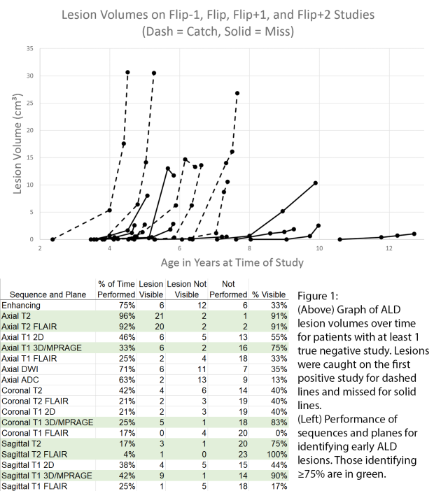

(9) Submission ID#753861
Validating a Decision Flowchart for Primary Cerebellar Tumors in a Paediatric Population: A Study from Two Tertiary Paediatric Hospitals
Submitter: CESAR ALVES – Children Hospital of Philadelphia
Author(s)
CESAR ALVES
Children Hospital of Philadelphia

Felice DArco
Great Ormond Street Hospital

Juan Sebastian Martin-Saavedra
Children's Hospital of Philadelphia

Ulrike Loebel
Great Ormond Street Hospital

Sara Teixeira
The Children's Hospital of Philadelphia

Sebastian Toescu
Great Ormond Street Hospital

Fabricio Guimaraes Goncalves, M.D.
Postdoctoral Fellow
The Children's Hospital of Philadelphia

Kshitij Mankad
Great Ormond Street Hospital

Arastoo Vossough
Children's Hospital of Philadelphia

Submission Topic
Brain - Tumors
Abstract
Purpose:
The goal of this study is to evaluate the diagnostic accuracy of a proposed flowchart¹ based on the signal, location and demographic characteristics for differentiating the most common primary cerebellar tumors in children according to the World Health Organization(WHO) Central Nervous System(CNS) tumor classification.²
Methods and Materials:
We performed a retrospective cross-sectional study from two tertiary pediatric hospitals from January 2013 to January 2019 at The Childrens Hospital of Philadelphia and Great Ormond Street Hospital. Eligibility criteria were subjects < 18 years of age having a pathological and molecular confirmed diagnosis of primary brain MRI tumors from the cerebellum according to 2016 WHO classification. CNS tumors were evaluated following a step-by-step numerical flowchart according to tumor location; Apparent Diffusion Coefficient, internal architecture, contrast enhancement, and patients age.(Figure 1) Cases were evaluated by two blinded readers at each institution. Agreement between readers was evaluated with the Kappa test. Disagreement in the evaluation was solved by consensus and final results were used to calculate sensitivity and specificity of the tool to identify the different types of tumors.
Results:
One hundred and forty-eight subjects were included. The mean age was 6.3 years-old, SD:5.5 years-old, male:female ratio 1.24:1. Fifty-four(36.5%) patients have histological diagnosis of medulloblastomas, 56 (37.5%) of pilocytic astrocytoma, 12(8.1%) of atypical teratoid rhabdoid tumor(AT/RT), 19(12.8%) ependymomas, 1(0.7%) low grade glioma(LGG) and 6(4.1%) other diagnosis. Agreement between readers at each institution was almost perfect(K = 0.96, p < 0.001) The sensitivity and specificity of the flowchart to identify the different type of tumors is described in Table 1. Also, the main pitfalls and exceptions to the algorithm based on clinical experience have been categorized and can be potentially incorporated in future diagnostic decision support algorithms.
Conclusions:
Diagnostic performance of the flowchart has demonstrated high accuracy for the diagnosis of cerebellar tumors, thus representing a good tool for prediction of the final diagnosis of these tumors according to 2016 WHO classification. A very strong agreement was also observed between readers from both institutions. This study shows that a flowchart can be used as a help for radiologists and to develop artificial intelligence-based models to differentiate cerebellar tumors according to the main imaging features.
1. DArco, F. et al (2018). Differential diagnosis of posterior fossa tumors in children: new insights. Pediatr. Radiol. 48.
2. Louis, D.N. et al. (2016). The 2016 World Health Organization Classification of Tumors of the Central Nervous System. Acta Neuropathol.
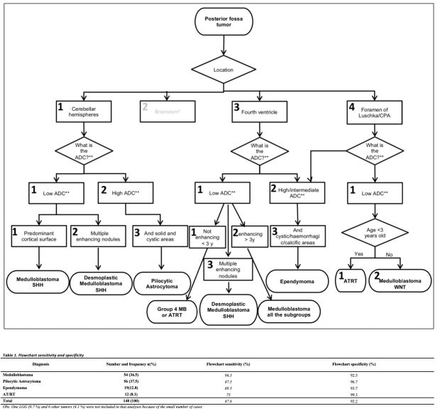

(10) Submission ID#755021
Fetal MRI Morphological Scoring System for Isolated Corpus Callosum Agenesis: Correlation with Neurodevelopment Outcome
Submitter: Mariana Diogo – Medical University of Vienna
Author(s)
Sarah Glatter
Researcher
Medical University of Vienna

Mariana C. Diogo
PhD Researcher
Medical University of Vienna

Daniela Prayer
Medical University Vienna

Michael Weber
Medical University of Vienna

Dieter Bettelheim
Medical University of Vienna

Rainer Seidl
Professor
Medical University Vienna

Gregor Kasprian
Medical University Vienna

Submission Topic
Brain - Developmental
Abstract
Purpose: Predicting outcome in children with agenesis of the corpus callosum (ACC) remains a challenge. Until now, prenatal imaging was unable to reliably identify those 20% of isolated ACC cases, who reportedly suffer from significant cognitive impairments postnatally. In this prospective study, a novel fetal MRI based scoring system was applied to predict neurodevelopmental outcomes in complete and/or partial ACC cases, which were classified as isolated by state-of-the-art prenatal neuroimaging.
Methods: We created a scoring system, based on anatomical fetal brain features, tailored to assess isolated CCA cases, using standard MRI images. It consisted of eight categories: gyration, opercularization, temporal asymmetry, lamination, hippocampal changes, basal ganglia, ventricular enlargement, and presence of blood products, translating minor anatomical features in a 0-3 points score, with a maximum attainable score of 16 points. MRI features were scored independently by two neuroradiologists, blinded to the neurodevelopmental outcome, using a standard fetal MRI protocol (T2, T1, DWI, EPI). Outcomes were tested by a neuropediatrician and/or psychologist using Bayley Scale - Third Edition (BSID-III) and the Kaufman Assessment Battery for Children Second Edition (KABC-II), depending on the age of the children. Normal development by the BSID-III and the KABC-II was defined as a development quotient (DQ) score 85, moderate to severe developmental delay as a DQ score < 70.
Results: A total of 21 patients were included. Average gestational age at MRI was 26 gestational weeks (SD: 4,38). Average age at postnatal evaluation was 24.5 months (range: 7-69 months). Neurodevelopmental cognitive outcome was normal in 71% (15/21) and motor outcome was in the average range in 67% (14/21) of the children. There was significant negative correlation between ACC MRI-Score and neurodevelopmental outcomes for cognition (r = -.66, p = .01) and motor skills (r = -.55, p = .04). All patients could be classified by MR Score in three predicting outcome groups: good, moderate and severe. Specific fetal MR features seem to correlate to deficits in certain neurocognitive and social-behavioral domains.
Conclusion: Standard prenatal diagnosis fails to detect 1/5 of cases classified as isolated CCA that will develop significant developmental delays. The proposed MR based score improves the prognostic value of fetal MRI, using sequences that are available at all centres, possibly improving pre-natal counselling of patients with partial and/or complete isolated callosal agenesis.
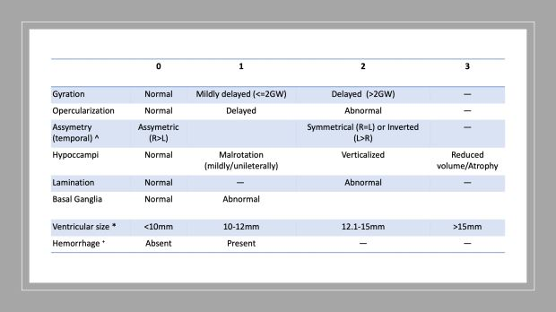
(11) Submission ID#755024
Application of Morphological MRI Score to Four Corpus Callosal Agenesis Sub-groups (Complete, Partial, Associated and Isolated): Correlation with Patient Outcome
Submitter: Mariana Diogo – Medical University of Vienna
Author(s)
Mariana C. Diogo
PhD Researcher
Medical University of Vienna

Sarah Glatter
Researcher
Medical University of Vienna

Michael Weber
Medical University of Vienna

Daniela Prayer
Medical University Vienna

Dieter Bettelheim
Medical University of Vienna

Rainer Seidl
Medical University of Vienna

Gregor Kasprian
Medical University Vienna

Submission Topic
Brain - Developmental
Abstract
Purpose: To apply an MRI based anatomical scoring system and compare the scores in CCA patients between four groups (isolated complete and partial, and associated complete and partial). We aimed to assess and apply the scoring system to a varied cohort of CCA patients subjected to fetal MRI and correlate the results with patient outcome.
Methods: Prospective collection of all cases of CCA who underwent fetal MRI between 2011 and 2019 in a tertiary care center. CCA cases were grouped in four groups according to MRI findings (in consensus by two neuroradiologists): isolated complete and partial and associated complete and partial. A 16-point score was applied based on T2-weighted single shot feat spin echo images directed at the fetal brain, T2-weighted fluid attenuated inversion recovery (FLAIR) and echo planar imaging. Scoring was independently performed by two neuroradiologists with experience on fetal MRI. Patient outcome was collected by a structured systematic phone questionnaire applied to the parent/legal guardian. Pearson correlation was used to correlate the MRI score and outcome and comparison of scores between groups was performed using a two-way ANOVA.
Results: Average gestational age was 27 GW (range 19+4 to 37+1 GW). A total of 130 cases were included (Isolated n= 66 [Partial n= 25, complete n= 41], associated n= 56 [Partial n= 31, complete n= 25]). Average Score for isolated CCA was 2.91±1.95 (Partial= 2.08±2.01, complete= 3.52±1.68) and higher for associated CCA 6.47±3.08 (Partial= 6.13±3.42, complete= 6.83±2.67). There was a significant difference in average total score between isolated and associated cases (p< 0.01). There was no moderation effect. These groups showed statistically significant difference between complete and partial isolated cases (p= 0.001) but not between complete and partial associated cases (p= 0.33).
Conclusion: Based on anatomical score alone, it is possible to categorize isolated complete, isolated partial and associated CCA. These results showed good correlation with neurological outcome in the surviving children. Adding the fetal MRI score to the everyday assessment of CCA may aid in patient counselling.

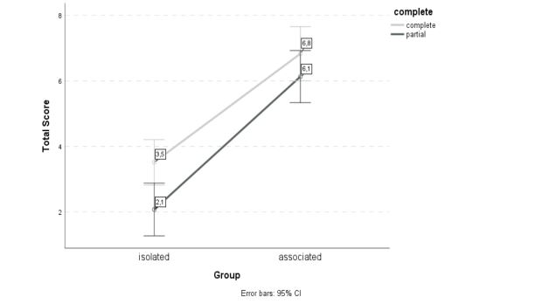

(12) Submission ID#755098
Concordance Rate in Adolescent Twins Informs Genetic Basis for Prominent Perivascular Spaces Risk
Submitter: Nicholas Stabo – University of Wisconsin - Madison
Author(s)
Zhan Luo
Graduate Research Assistant
University of Wisconsin Madison

Nicholas Stabo
University of Wisconsin - Madison
.
Andrew Alexander
University of Wisconsin Madison
.
Aaron Field
University of Wisconsin - Madison

H. Hill Goldsmith
University of Wisconsin Madison

Howard Rowley
University of Wisconsin School of Medicine and Public Health

Submission Topic
Brain - Developmental
Abstract
Purpose: Prominent perivascular spaces (PVS) are a normal anatomical variant also associated with a wide range of neurological conditions. We compared the concordance rate for prominent PVS among monozygotic (MZ) and dizygotic (DZ) twin pairs to infer the genetic and environmental contributions of prominent PVS risk.
Methods and Materials: Magnetic resonance images (MRI) were acquired at 3T from a healthy community sample of adolescents born in Wisconsin and recruited using statewide birth records. 506 monozygotic and same-sex dizygotic twin individuals aged 13-20 were included. A board certified radiologist and a senior radiology resident who were blinded to the zygosity of the twin pairs reviewed 3D T1-weighted images (1 mm slice thickness) for the presence of prominent PVS. Prevalence and concordance rates among MZ and DZ twin pairs were calculated.
Results: 127 (25%) twin individuals had prominent PVS. Males (33%) were more likely than females (18%) to be affected (p< 0.05). The proband-wise concordance rate, which denotes co-twin risk, was 83% for monozygotic pairs and 52% for dizygotic pairs.
Conclusion: Cotwins of monozygotic and dizygotic twins with prominent PVS have approximately 3.3- and 2- fold increased risk, respectively, of also having the condition compared with the full sample prevalence rate (25%). The higher concordance rate among MZ twins compared to DZ twins, who on average only share half of genes identical by descent, suggests genetic risk factors play a key role in the development of prominent PVS.
Table 1: Sex Differences of prominent PVS
 |  | Prominent PVS |  | Total
 |  | Absence | Presence | Total
Sex | Female | 216 | 46 | 262
Sex | Male | 163 | 81 | 244
Total |  | 379 | 127 | 506

Table 2: Concordance rates for prominent PVS
Zygosity | No. Pairs Concordant | No. Pairs discordant | Proband-wise Concordance | Pairwise Concordance
MZ Pairs | 32 | 13 | 0.83 | 0.71
DZ Pairs | 13 | 24 | 0.52 | 0.35

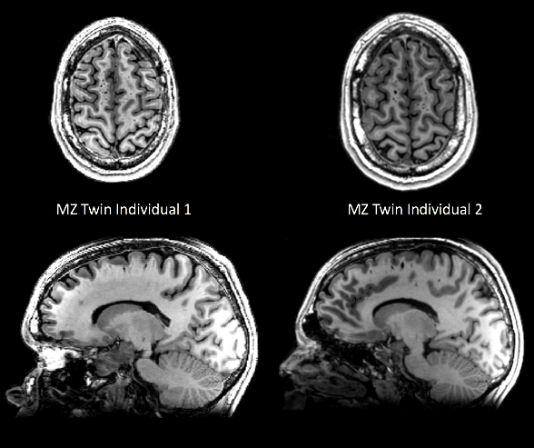

(13) Submission ID#755319
Voxel-based Lesion Mapping of Inter-Arterial Watershed Areas in Patients with Hypoxic-Ischemic Injury
Submitter: Christian Barrera – Children's Hospital of Philadelphia
Author(s)
Christian A. Barrera, M.D.
Pos Doctoral Fellow
Children's Hospital of Philadelphia

Anith Chacko, M.D, MBBCh, FCRad
Clinical Research & Imaging Centre, Bristol Medical School

Fabricio Guimaraes Goncalves, M.D.
Postdoctoral Fellow
The Children's Hospital of Philadelphia

Ngoc Thai-Goodson, PhD
Senior Research fellow
University of Bristol

Savvas Andronikou, MBBCh, FCRad, FRCR, PhD, PhD
Vice Chair of Clinical Research and the John W Hope Endowed Chair
The Children's Hospital of Philadelphia
Submission Topic
Brain - Cerebrovascular
Abstract
Purpose: To map the MRI distribution of inter-arterial watershed in the brain
Materials and Methods: In this cross-sectional study, patients between 0 18 years old with confirmed prior peri-natal partial-prolonged hypoxic-ischemic injury and available T2-weighted MR images were included. Those patients with massive ventriculomegaly, multi-cystic encephalomalacia, and generalized ischemic injury were excluded. Two pediatric neuroradiologists mapped the involved areas on T2-weighted images using ITK-SNAP (University of Pennsylvania, PA). These were defined as areas with localized atrophy, ulegyria, and/or signal abnormality in the brain parenchyma, excluding the deep nuclei. These were manually segmented using a region of interest tool by the neuroradiologists (in consensus) for each patient individually. The segmented regions and T2-weighted images were subsequently co-registered and normalized to a 1.0-mm isotropic, high-resolution, age-matched T2-weighted brain atlas provided by the University of South Carolina using an algorithm with a 12-degree of freedom transformation using SPM 12 (University College London, UK). A composite color heatmap was created and superimposed on the same brain atlas using MRIcron (University of South Carolina, SC) corresponding to the topography and frequency of lesion presence for the whole patient population.
Windowing was set to (a) either reflect the maximum extent of involvement from partial prolonged hypoxic-ischemic injury which included areas involved less frequently (in blue) [Fig 1a] or (b) to demonstrate the areas involved with the highest frequency (red) [Fig 1b].

Results: 24 patients (18 boys, 6 girls) with a mean age of 8.6 (SD ± 3.1) years were included. Topographic heat maps demonstrated the watershed involved in partial prolonged hypoxic-ischemic injury as a continuum extending from the superior frontal sulcus anteriorly, through the parasagittal and deep watershed of the frontal lobes and the perisylvian end zone of all three major arterial territories, to the inter-arterial watershed between the middle cerebral and posterior cerebral arteries posteriorly.
Limitations of the current technique include misregistration of the combined segmented regions onto the brain atlas with apparent sparing of the cortical ribbon. This will be corrected in future iterations.
Conclusion:
Windowing allowed demonstration of the full range of the extent of parenchymal involvement in partial prolonged hypoxic-ischemic injury. More importantly, narrowing the window to reflect areas involved most frequently allowed demonstration of the band of parenchyma between the main arterial territories - the true watershed continuum.
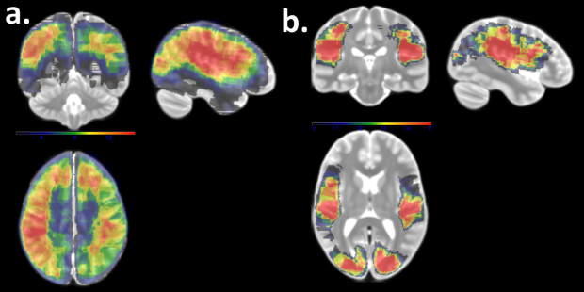

(14) Submission ID#755603
Ultrasound Evaluation of Intracranial Hemorrhage in Preterm Infants
Submitter: Bhanupriya Singh – Ram Manohar Lohiya Institute of Medical Sciences
Author(s)
Bhanupriya Singh, N/A, n/a
Senior Resident
Ram Manohar Lohiya Institute of Medical Sciences

Submission Topic
Brain - Other
Abstract
Purpose
- Determine the frequency of IVH in preterm neonates
- Grade IVH on cranial ultrasound
- Assess the timing of injury
- Sequelae at the end of one month
Methods and Materials
- Prospective study, 100 preterm babies
- Gestational age < 32 weeks& Birth weight < 1.5 kg
With Philips Envisor CHD and Mindray
- ultrasound units using 3.5 to 5 MHz convex,
- 7.5-10MHz linear probes
Results
Of the 112 premature infants evaluated, 32 demonstrated intraventricular bleed extending till germinal matrix. Out of these 32, 10 showed formation of subependymal cysts during 4 week follow up sonography. 1 patient showed subdural bleed on 4 week follow-up scan. It was not picked up on 48 hours sonogram. 1 infant had diffuse ischemia affecting both the cerebral hemispheres. Cerebellum was preserved from ischemia. 3 infants showed hydrocephalus which returned to normal on follow up scan at 4 weeks. 75 infants showed normal findings at 48 hours and 4 weeks neurosonogram scans.
Conclusion

Clinical neonatal seizures occur 6 times more often in preterm infants than in term infants. Hypoxic-ischemic encephalopathy is the major cause of seizure in term infants [12] where as intraventricular bleed is the most common cause in preterm infants. In our series of patients too we found intraventricular bleed as the leading cause. Both bleed and ischemia are easily picked up easily on neurosonogram. Seizure in preterm infants has a poor prognosis with more than 50% mortality and about 22% with major neurological disability. [11, 13, 14]. Aggressive treatment is needed to treat neonatal seizures and hence neurosonogram plays an important role in diagnosing the common causes. Neurosonogram being a bedside and easily available imaging modality further makes it more preferred by clinicians as compared to CT scan or MRI.

(15) Submission ID#755780
Neuroimaging and Clinical Outcomes in Abusive Head Trauma
Submitter: Poe Phyu – Cambridge hospitals
Author(s)
Poe Z. Phyu
neuroradiologist
Cambridge hospitals

Mariana Planells Alduvin
Great Ormond street hospital

Kshitij Mankad
Great Omond street hospital

Submission Topic
Brain - Trauma
Abstract
Purpose
Abusive Head Trauma (AHT) is an inflicted condition, predominantly occurring in children younger than two years old. As per reported literature, there is a wide spectrum of potential clinical outcomes associated with AHT ranging from complete functional recovery to death. To our knowledge, there is no study which correlates long term neuroimaging findings with clinical outcomes in surviving children with AHT. The purpose of our study was to describe long term neuroimaging findings and evaluate the association between neuroimaging and clinical outcomes.
Methods
All children admitted to Great Ormond Street Hospital with either imaging or clinical suspicion of AHT were retrospectively identified using clinical and imaging records. Two experienced neuroradiologists blinded to the clinical outcome analysed all available CTs and MRIs performed during admission and at follow up visits. The appearance of abnormalities on initial imaging and their evolution over years were recorded on serial neuroimaging studies. The long term clinical outcomes such as motor and visual impairment, developmental delay and seizure disorders were assessed during follow up visits.
Results
Fifty-nine children (31 males and 28 females) with suspected AHT were identified. Eight children with severe AHT died. Thirty-four patients had clinical follow-up, ranging from 8 months to 14 years. 19 patients had neuroimaging at follow-up ranging from 1 year to 14 years. The most common imaging findings included generalized cerebral atrophy (11 patients), focal/regional cystic leukomalacia (8 patients) and chronic bilateral subdural collections (8 patients).
Thirty-two patients presented with long term multiple neurological morbidities. Our results showed motor problems in 12 patients, visual impairment in 14 patients, developmental delay in 14 patients and seizure disorders in 15 patients. Two patients showed no clinical impairment.
18/19 patients with available neuroimaging findings showed long term neurological impairments. All eight patients with persisting bilateral subdural haematomas were affected: developmental delay (5 patients), visual abnormalities (2 patients), motor disorders (3 patients) and seizures (5 patients). 10/11 patients with cerebral atrophy showed marked neurological impairment: developmental delay (6 patients), visual impairment (4 patients), motor impairment (3 patients) and seizures (6 patients).
Conclusions
Our study showed strong correlation between long-term neuroimaging appearances and adverse clinical outcomes. At present there is no protocol for imaging follow-up of these children, and we propose follow-up scanning at one year after the initial presentation for better clinical characterisation and prognostication.
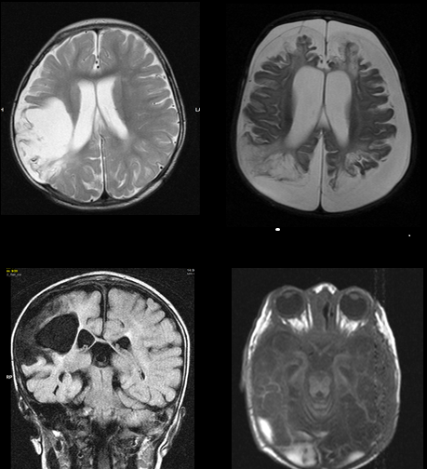

(16) Submission ID#755797
Association Between Payer Status and CT Utilization for Headache in a Large Pediatric Health System
Submitter: Donald Chan – University of Texas Southwestern Medical Center
Author(s)
Donald Chan, EdM
Medical Student
University of Texas Southwestern Medical Center

Nishika Karbhari, BS
Medical Student
University of Texas Southwestern Medical Center

Cory M. Pfeifer
University of Texas Southwestern Medical Center

Submission Topic
Misc - Workflow, Economics, Informatics, etc.
Abstract
Purpose
Head CT is commonly used to evaluate headaches in emergency departments. However, it is not recommended as a first test to evaluate most non-traumatic headaches in children unless the headache is acutely severe. While CT studies can provide important diagnostic information, they expose patients to radiation and increase healthcare expenses. According to the existing literature, there may be differences in CT utilization based on patient insurance status. The purpose of this investigation is to evaluate the association between insurance type and the likelihood of receiving a head CT scan for headache in a single pediatric hospital system.
Methods and Materials
The study included patients who presented with a chief complaint of headache at either of two pediatric emergency departments affiliated with a large pediatric healthcare system. Patients with a history of trauma, charity care patients, and self-pay patients were excluded. We developed a multivariate logistic regression model. The outcome variable was whether or not the patient received a head CT scan. The predictor variables were insurance type (private or government) and hospital location (urban main or suburban satellite).
Results
333 patients presented with headache during the period studied. 38 patients total (11%) received a head CT scan, comprising 23 of 100 patients (23%) with private insurance and 15 of 233 patients (6%) with government insurance. On multivariate logistic regression, after controlling for the location of the hospital, having private insurance was independently associated with a higher probability of receiving a head CT scan. The odds ratio of CT imaging in patients with commercial compared to government insurance was 3.72.
Conclusions
Privately insured children who presented with headache were 3.72 times as likely to receive head CT imaging compared to those with government insurance. Multiple patient- and provider-driven factors may contribute to this difference. Parents of children with commercial insurance may have higher socioeconomic status, education, and familiarity with imaging. These factors may influence them to request more imaging. As to provider effects, physicians may order more imaging for privately insured patients because of possible implicit bias, insurance reimbursement concerns, and/or litigation risk. The limitations of our study included our inability to control for patient race or provider variability. The difference in the likelihood of imaging raises concerns about health care disparities between children with government insurance and those with private insurance as well as greater risk of radiation exposure among those with private insurance.

(17) Submission ID#755921
Morning Glory Optic Disc Abnormality: Spectrum of Associated Anomalies and Characteristic Imaging Findings
Submitter: Michael Kushdilian – Indiana University School of Medicine
Author(s)
Michael Kushdilian
Resident
Indiana University School of Medicine

Joseph Acchiardo
Indiana University School of Medicine

Chang Ho, MD
Staff Radiologist
Indiana University School of Medicine

Rupa Radhakrishnan, MD
Staff Radiologist
Indiana University School of Medicine
Submission Topic
Brain - Developmental
Abstract
Purpose: Morning glory disc anomaly (MGDA) is a rare congenital anomaly of the posterior globe with characteristic excavation of the optic disc resembling the flower of the same name. There have been few case reports of intracranial and extracranial anomalies associated with MGDA. In this study, we performed a retrospective review of associated abnormalities in patients with MGDA who underwent MR imaging at one of our institutions.
Methods and Materials: We performed an IRB-approved retrospective case review from direct (morning glory disc) or indirect (coloboma) keyword searches of radiology reports from across our multicenter database of MR imaging of cases of MGDA. Two pediatric neuroradiologists performed a consensus agreement of radiologically described MGDA for these cases. Ophthalmologic records, when available,were obtained and reviewed for corroboration. All available imaging (MRI and CT) in these patients was reviewed for associated anomalies. Medical records were scrutinized for any other multisystem associations or syndromes.
Results: We identified 13 patients with MGDA who had MR imaging of the brain and orbits. MGDA was unilateral in 12 patients. Ophthalmologic corroboration was available for the majority of patients. The most common mimics of MGDA were optic pits and posterior colobomas. In confirmed cases of MGDA, associated abnormalities were present in 8 of these 13 patients (62%). These included ipsilateral persistent hyperplastic primary vitreous (1/13 patients), persisting embryonal infundibular recess (1/13), and facial vascular malformations (3/13). Only three patients demonstrated vasculopathic changes, including one that met criteria for moyamoya disease. None of the patients exhibited abnormalities of the corpus callosum, palate, or skull base.
Conclusion: The majority of patients with MGDA demonstrated associated anomalies including those of the ipsilateral orbit, optic pathway, intracranial parenchymal or vascular systems. Therefore, identification of MGDA should necessitate a thorough search for other associated intracranial and extracranial anomalies.The radiologist should become familiar with the imaging of MGDA and its differentiation from common mimics.
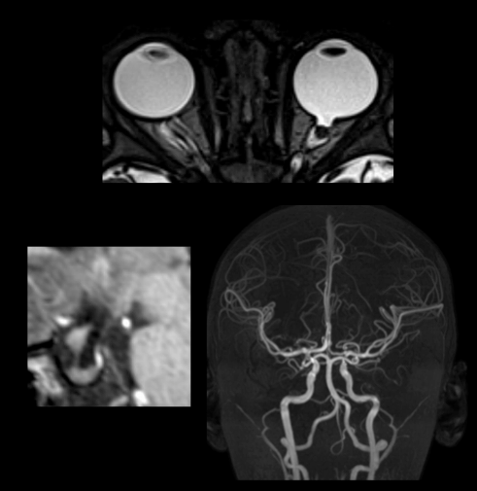

(18) Submission ID#755941
Vigabatrin Neurotoxication in Treatment of Child Spasms - Two Cases Report
Submitter: Antonio Gomes Lima Júnior – Hospital Antonio Prundente
Author(s)
Antonio Gomes Lima Júnior
Doctor
Hospital Antonio Prundente

Pablo Picasso de Araújo Coimbra
Hospital Geral de Fortaleza

Nina Maia Pinheiro de Abreu
UNIFESP

Laura Vitória Melo Gomes
Faculdade Atenas

Lucas Olimpio Coimbra
Unichristus

Hilanne Linhares Andrade de Aquino
Hospital Antonio Prundente
Submission Topic
Brain - Other
Abstract
Vigabatrin is an irreversible inhibitor of GABA transaminase, which increases GABA concentration, an inhibitory neurotransmitter that decreases epileptogenic circuits and seizure frequency in patients with infantile spasms. Reported side effects of Vigabatrin include headache, drowsiness, fatigue, dizziness, and visual field abnormalities. Poisoning can affect about 20-30% of patients with infantile spasms and is described by the reversible T2 hyperintensity and / or restricted diffusion in the pale globe (most common), dentate nuclei, thalamus, corpus callosum, midbrain and brainstem. Magnetic resonance imaging changes appear within about five weeks of initiation of the use and may disappear completely after three months, even without discontinuation. All affected patients were treated for infantile spasms. In one of the largest studies on the subject, none of the patients treated for infantile spasms with other medications who were not treated with vigabatrin showed these abnormalities. These changes have been observed as asymptomatic and reversible.
Our study aims to report two cases of female patients on current use of vigabatrin for treatment of infantile spasm for at least 6 months who underwent brain magnetic resonance imaging for follow-up of the spasm. without any specific complaints. Such exams presented alterations in the brain resonance images compatible with those described in the literature, such as alterations in T2 / FLAIR, associated with bilateral diffusion of pale globes, midbrain and pontine tegmentum. No significant enhancement after contrast medium injection. Given the absence of other causes, such changes were related to the use of Vigabatrin, and the segment of one of them showed the reversibility of the neuroimaginological picture. One of the patients underwent proton spectroscopy study without significant changes in metabolic peaks. Vigabatrin poisoning may appear with metabolic spike of the glutamine-glutamate complex in the proton spectroscopy study (2.2 - 2.4 ppm).
Within this context, one of the important differential diagnoses would be alterations by nonketotic hyperglycemia, in which spectroscopy serves as a diagnostic method and treatment control, by glycine peak (peak at 3.55 ppm) and T2 much longer than myo-inositol. (3.56 ppm), not being possible to be evaluated alone in the sequences with short TE, but remaining its peak in long TE. Another differential diagnosis would be maple syrup urine disease, in which spectroscopy can elucidate the diagnosis, as the peak of cytozolic amino acids - 0.9 ppm may appear.
The importance of radiologists' knowledge of this type of neurometabolic alteration and its main imaging characteristics should be recognized.

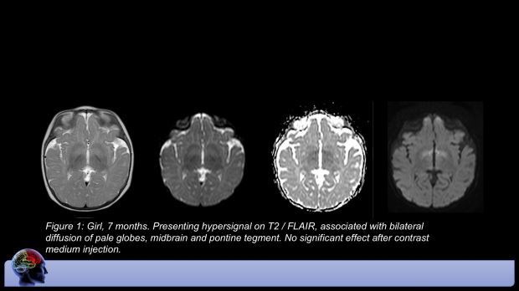

(19) Submission ID#755990
Clinical Utilization of a Rapid Stroke MRI Protocol in a Pediatric Emergency Department
Submitter: Ben Steyer – UNIVERSITY OF WISCONSIN-MADISON
Author(s)
Benjamin Steyer
University of Wisconsin School of Medicine and Public Health

Richard Bruce
University of Wisconsin School of Medicine and Public Health

Howard Rowley
University of Wisconsin School of Medicine and Public Health

John-Paul Yu
University of Wisconsin School of Medicine and Public Health

Submission Topic
Misc - Workflow, Economics, Informatics, etc.
Abstract
Purpose:
Rapid imaging evaluation is critical for pediatric patients presenting with acute neurologic or stroke-like symptoms. Computed tomography (CT) is widely used in this regard, however, there has been increased interest in utilizing rapid magnetic resonance imaging (MRI) protocols in these patients as MRI has improved sensitivity for detection of acute ischemia and eliminates radiation exposure. While prospective studies of rapid MRI stroke protocols have been conducted in controlled patient populations, there has been minimal analysis of the application of these protocols in general clinical practice, especially in pediatric patient populations. A greater understanding of the real-world usage of these protocols is needed to evaluate their clinical utility.
Materials and Methods:
A rapid stroke MRI protocol (< 10 minutes) was introduced in our pediatric emergency department (ED) in January 2017. We conducted two-year retrospective chart review of all 0-19 year-old patients who presented to the ED with a chief complaint (CC) of either headache or stroke symptoms in the year prior to implementation of the rapid stroke MRI protocol and for the year immediately following implementation of the rapid MRI protocol. The primary outcomes were percent of patients undergoing neuroimaging, imaging modality, time from arrival to completion of initial imaging, and time to disposition (i.e. discharge, observation, or admission).
Results:
The number of 0-19 years old patients presenting to the ED with headache or stroke symptoms was 318 in 2016 and 354 in 2017 (Table 1). The rate of neuroimaging was 28% (88 patients; 91 ED encounters) in 2016 and 26% (91 patients; 101 ED encounters) in 2017. Within our patient population, zero rapid stroke MRI protocols were performed in 2016 versus 17 during 2017. The usage rate of CT as an initial imaging modality was 44% in 2016 versus 30% in 2017. Additionally, average time to completion of imaging was 3.8±0.3 hours in 2016 versus 2.6±0.2 hours in 2017 and average time to disposition was 5.1±0.2 hours in 2016 and 4.9±0.3 hours in 2017.
Conclusions:
Introduction of a rapid MRI stroke protocol in our pediatric ED resulted in a reduction in time to completion of initial imaging and a decreased rate of CT imaging in 0-19 year-old patients presenting with either headache or stroke symptoms. No concomitant increase in imaging rate and no increase in ED dwell time was observed in these patients. Collectively, these results support the utility of rapid MRI imaging for stroke screening in this population.

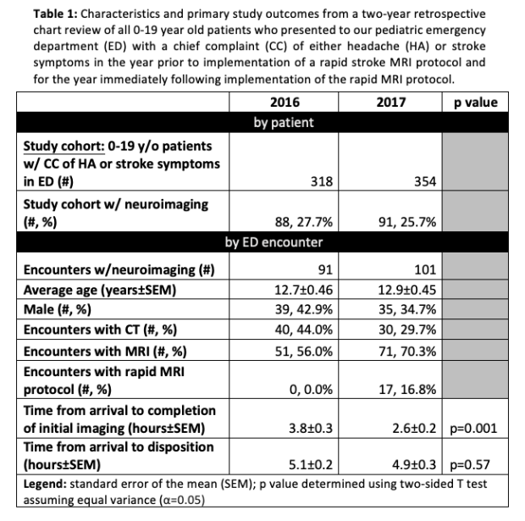

(20) Submission ID#756013
Temporal Encephalocele: A Treatable Etiology of Pharmacoresistant Pediatric Temporal Lobe Epilepsy
Submitter: Ersida Buraniqi – Mayo Clinic
Author(s)
Ersida Buraniqi, MD
Child Neurology Resident
Mayo Clinic

Julie B. Guerin, MD
Mayo Clinic

Karl Krecke, MD
Mayo Clinic

Lily Wong-Kisiel, MD
Mayo Clinic
Submission Topic
Brain - Epilepsy
Abstract
Purpose: Temporal lobe encephaloceles (TEs) are defined as a pathological herniation of brain parenchyma through a structural defect in the middle cranial fossa. They are a rare cause of pharmacoresistant temporal lobe epilepsy in adults but not well described in pediatric epilepsy. The purpose of this study is to describe temporal encephalocele in children with temporal lobe epilepsy, to outline radiographic features of these cases, and to report surgical treatments in our cohort.
Materials and Methods: We retrospectively reviewed patients with epilepsy and temporal encephalocele on brain imaging, who were between 0 and 18 years of age at Mayo Clinic Childrens Center from 2008 to 2018. Data was collected on demographics, brain imaging features and surgical outcomes.
Results: Eight patients diagnosed with temporal encephaloceles (TE) were identified. The median age at epilepsy onset was 10.5 years [IQR 8.5-13.5 years]. Latency between epilepsy diagnosis and definite TE diagnosis had a median of 4 years (range of 0-17 years). Our patient series had a mean BMI of 26. Half of the patients had risk factors for seizures including febrile seizures, family history of seizures, previous traumatic brain injury, or perinatal infection. The most common seizure types were focal epilepsy with or without secondary generalization with temporal region onset. Our entire cohort had associated comorbidities including depression, anxiety and learning disabilities. Of the patients who had surgery (6/8), 83% (5/6) were seizure free with Engel outcome IA with mean duration of 16.7 months follow-up after surgery. One patient had 90% seizure frequency reduction up to 2 years after encephalocele resection and repair. More than one third (38%) of the patients were diagnosed based on epilepsy surgery conference re-review. Three quarters of the patients were on an average of two antiepileptic drugs at the time of diagnosis. All of the patients (8/8) had protrusion of CSF and distorted/gliotic brain parenchyma through an osseous defect in the floor of the middle fossa without frank osseous dehiscence. In 50% of the cases, there was associated regional FDG hypometabolism on brain PET imaging. No patient had bilateral TE.
Conclusions: We conclude that temporal lobe encephalocele is a missed cause of drug-resistant temporal lobe epilepsy in childhood. All patients had a unilateral temporal lobe encephalocele. All herniations were contained defects without osseous dehiscence. Of the patients who had surgery, 83% were seizure free at last follow-up.
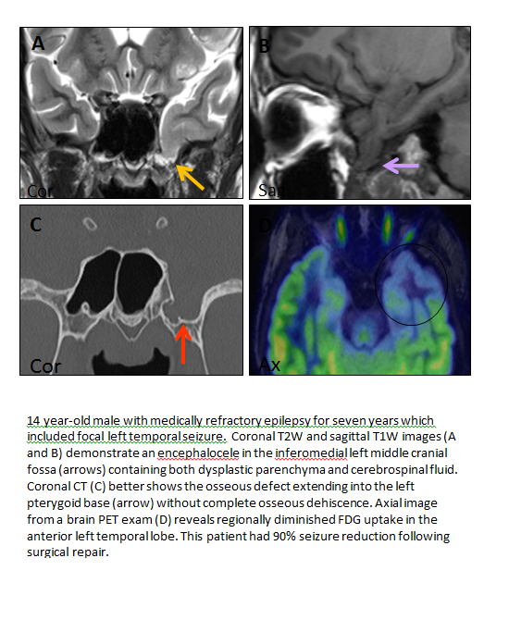
(21) Submission ID#756064
MRI-based Radiomics Prognostic Markers of Diffuse Midline Glioma
Submitter: Andrew Campion – Stanford
Author(s)
Andrew Campion
Stanford University

Lydia Tam
Stanford University

Jason Wright
Stanford University

Katie Shpanskaya, BA
Stanford University School of Medicine

Michelle Monje
Stanford University

Gerald Grant
Stanford University

Nick Vitanza
Stanford University

Sarah Mattonen
Western University

Kristen W. Yeom, MD
Pediatric Neuroradiologist
Stanford University

Submission Topic
Brain - Tumors
Abstract
Purpose:
Diffuse midline glioma (DMG), formerly diffuse intrinsic pontine glioma (DIPG), is a lethal pediatric brain tumor with dismal prognosis. Presently, MRI is the mainstay of disease diagnosis and surveillance. Our goal was to extract high-dimensional MRI features to identify prognostic image-based radiomics markers of DMGs and compare the performance of these markers to clinical variables at presentation.
Methods and Materials:
We assembled brain MRIs of treatment-naïve pontine-origin DMGs from two pediatric hospitals for this retrospective study. We isolated tumor volumes of T1-weighted post-contrast (T1gad) and T2-weighted (T2) MRI sequences for high-dimensional feature extraction using PyRadiomics¹. We extracted 900 features on each image comprising 1st order statistics, 2D/3D Shape, Gray Level Co-occurrence Matrix (GLCM), Gray Level Run Length Matrix (GLRLM), Gray Level Size Zone Matrix, Neighboring Gray Tone Difference Matrix, and Gray Level Dependence Matrix, as defined by Imaging Biomarker Standardization Initiative (IBSI)². Overall survival (OS) served as primary outcome. 10-fold cross-validation of LASSO Cox regression was used to predict OS (glmnet packaged R Software). We analyzed performance of our model using clinical variables (patient age at diagnosis and patient sex) only, radiomics only, and radiomics plus clinical variables. Concordance metric was used to assess the Cox model.
Results:
68 children (median age 6.6 years; 32 males; n= 37 Stanford; n= 31 Seattle Childrens) met the inclusion criteria. Mean OS was 11.67 (Stanford) and 12.59 (Seattle) months. Five radiomic features were selected: 1 feature from T2 (wavelet first-order feature) and 4 features from T1gad (two wavelet GLRLM texture features; 1 wavelet GLCM texture feature; 1 log-sigma 1storder feature). Radiomics features alone and radiomics features plus clinical variables were predictive of survival outcome.
 | C-Index | Log-Rank p
Clinical Only | 0.624 | 0.06
Radiomics Only | 0.711 | 0.001
T1 only | 0.678 | 0.006
T2 only | 0.627 | 0.02
Radiomics + Clinical | 0.714 | 0.002
Conclusions:
Our pilot study shows a potential role for MRI-based radiomics and machine learning for future DMG risk stratification and as image-based biomarkers for clinical therapy trials.
References:
1. Van Griethuysen JJ, Fedorov A, Parmar C, Hosny A, Aucoin N, Narayan V, Beets-Tan RG, Fillion-Robin JC, Pieper S, Aerts HJ. Computational radiomics system to decode the radiographic phenotype. Cancer research. 2017 Nov 1;77(21):e104-7
2. Zwanenburg, A., Leger, S., Vallières, M., and Löck, S. (2016). Image biomarker standardisation initiative - feature definitions. In eprint arXiv:1612.07003
(22) Submission ID#756086
Are ASL Perfusion and SPECT Examination Comparable in Lateralization of Seizure Focus in Pediatric Patients with Intractable Temporal Lobe Epilepsy?
Submitter: Ajay Garg – AIIMS, New Delhi, INDIA
Author(s)
Ajay Garg
Professor
AIIMS, New Delhi, INDIA

Khush Preet Bhullar, n/a
ALL INDIA INSTITUTE OF MEDICAL SCIENCES

Madhavi Tripathi
Additional Professor
AIIMS, New Delhi

Manjari Tripathi
AIIMS, New Delhi

Sarat P Chandra
AIIMS, New Delhi

Submission Topic
Brain - Epilepsy
Abstract
PURPOSE
To compare the diagnostic performance of ASL perfusion and SPECT examination in lateralization of seizure focus in pediatric patients with intractable temporal lobe epilepsy.
METHOD AND MATERIALS
Twenty one pediatric patients with intractable temporal lobe epilepsy underwent conventional MR examination on 3T scanner and ASL perfusion on 1.5 T scanner using 3D pseudocontinuous ASL. Interictal and Ictal SPECT examinations were done; dye was injected within 20 seconds of seizure for ictal SPECT. Ictal SPECT was subtracted from interictal SPECT and was co-registered with MR scan (SISCOM). The findings on conventional MR examination, ASL perfusion maps and SISCOM were noted to localize the seizure focus.
RESULTS
Total of 21 patients [Male: 14, Female: 7; mean age 13.47 (Range; 4-17 yrs)] were included. On conventional MR imaging, 3 patients had normal MRI, 4 had isolated medial temporal sclerosis (MTS) (R-2 and B/l-2), MTS with focal cortical dysplasia (FCD) (3), MTS with perinatal insult (2) and Type 1 FCD (9). SPECT showed ipsilateral temporal lobe (5), contralateral temporal lobe (2) and extra-temporal localization (7) patients. SPECT could not localize seizure focus in 7 patients. ASL perfusion was increased in 2 patients, decreased in 17 patients and normal in 2 patients. ASL perfusion maps showed ipsilateral temporal lobe (12), contralateral temporal lobe (2), no localisation (2) and extra-temporal localization (5) patients.
CONCLUSION
ASL perfusion maps are comparable of SPECT data in lateralization of the seizure focus in patients with intractable temporal lobe epilepsy and may replace the need to do SPECT examination.

(23) Submission ID#756111
Visual Pathway Evaluation in Kearns Sayre Syndrome: A Diffusion Tensor Imaging Study
Submitter: Maria Camilla Rossi Espagnet – Bambino Gesù Children's Hospital
Author(s)
Maria Camilla Rossi EspagnetMD
Bambino Gesù Children's Hospital

Martina Lucignani
Bambino Gesù Children's Hospital

Luca Pasquini
Bambino Gesù Children's Hospital

Chiara Carducci
Bambino Gesù Children's Hospital

Antonio Napolitano
Bambino Gesù Children's Hospital

Stefano Pro
Bambino Gesù Children's Hospital

Andrea Romano
Bambino Gesù Children's Hospital

Diego Martinelli
Bambino Gesù Children's Hospital

Daria Diodato
Bambino Gesù Children's Hospital

Daniela Longo
Bambino Gesù Children's Hospital

Submission Topic
Brain - Other
Abstract
Purpose: Kearns Sayre Syndrome (KSS) is a mitochondrial disorder characterized by development of visual impairment. Electroretinogram (ERG) and visual evoked potentials are not able to provide topographical informations of optic damage. The purpose of this retrospective study is to explore retrochiasmatic optic pathway alterations in KSS patients by mean of diffusion tractographic analysis.
Methods and Materials: DTI from 8 KSS subjects (14.7 y) and 10 agematched Healthy Controls (HC) were acquired on a 3T scanner. Optic radiations (OR) and optic tracts (OT) were reconstructed through constrained spherical deconvolution algorithm. Fractional Anisotropy (FA), Apparent Diffusion Coefficient (ADC), Radial (RD) and Axial Diffusivity (AD) were calculated and group differences were assessed with a single-side t-test. Two-sample t-test on diffusion parameters identified significantly different track portions among cohorts (p< .05). All patients had electrophysiological examination.
Results: All patients had optic pathway alterations at electrophysiological examination. Statistically significant differences of FA were found in OT with lower values in the KSS group (p< .002). RD was significantly higher in bilateral OR (p< .02) and right OT (p< .05), while ADC was higher in bilateral OR (p< .002). RD values were higher in the proximal and distal portion of the OR bilaterally and the distal portion of the right OT. No significant differences were found for AD. For FA and ADC significant differences between groups in several regions of OT and OR respectively.
Conclusions: DTI evaluation of retrochiasmatic tracks may represent a useful tool to topographically investigate retrochiasmatic visual impairment in KSS.
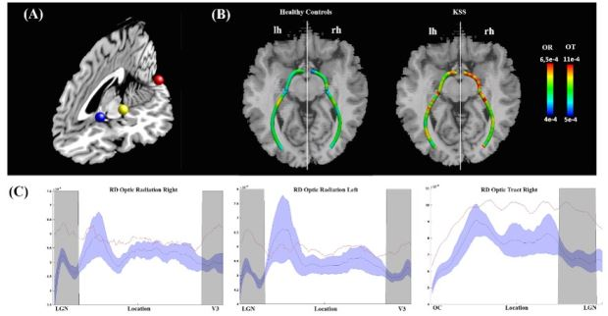

(24) Submission ID#756194
Temporal Bone and Intracranial Abnormalities in Syndromic Causes of Hearing Loss: An Updated Guide
Submitter: Felice D'Arco – Great ormond Street Hospital for Children
Author(s)
Felice D'Arco
Consultant Neuroradiologist
Great ormond Street Hospital for Children

Lorenzo Pinelli
Spedali Civili

Sotirios Bisdas
UCLH

Pablo Caro
University Hospital Seville

Robert Nash
Great Ormond street Hospital

Ata Siddiqui
evelina children's Hospital

Giacomo Talenti
Veronal University Hospital

Submission Topic
Head and Neck
Abstract
Purpose
To describe in detail the temporal bone and brain findings in both common and rare
syndromic causes of hearing loss using the new proposed classification system of cochlear malformations, with the purpose of broadening among radiologists and enhance the current understanding of characteristic imaging features in paediatric
patients with syndromic hearing loss.
Methods
A detailed search of electronic databases has been conducted, including PubMed,
Ovid Medline, Scopus, Cochrane Library, Google Scholar, National Institute for Health
and Care Excellence (NICE), Embase, and PsycINFO.
Results
Syndromic causes of hearing loss are characterised by different and sometimes
specific abnormalities in the temporal bone.
Conclusion
A complete knowledge of the image findings in the temporal bones, brain, skull and
other body regions is critical for the optimal assessment and management of these
patients.
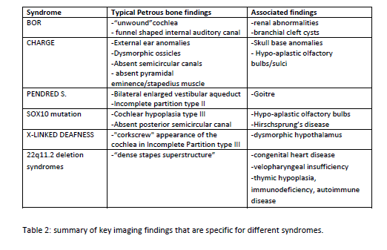

(25) Submission ID#756223
Imaging Findings in Patients with Genetic Causes of Holoprosencephaly
Submitter: Subramanian Subramanian – UPMC CHildren's Hospital of Pittsburgh
Author(s)
Subramanian Subramanian, MD
Assistant Professor
UPMC CHildren's Hospital of Pittsburgh

Deepa Soundara Rajan
Assistant Professor
UPMC, Children's Hospital of Pittsburgh

Andre D. Furtado
UPMC Children's Hospital of Pittsburgh

Ashok Panigrahy
Professor and Vice Chair
UPMC Children's Hospital of pittsburgh
Submission Topic
Brain - Developmental
Abstract
Purpose: To identify any characteristic imaging findings in patients with genetic causes of holoprosencephaly spectrum of disorders and incidence of olfactory system abnormality in these patients.
Materials and methods: Patient's with holoprosencephaly spectrum disorder are identified utilizing MARS database utilizing key words "Holoprosencephaly" and retrospective review of imaging findings and genetic mutations was performed by neuroradiologist after IRB approval. 24 patients had MRI and 8 patient had CT scan.
Results: There were 32 patients (26 females and 6 male) with a mean age of 6.3 years. Eight patients had lobar holoprosencephaly, 14 had semi-lobar holoprosencephaly, 2 had alobar holoprosencephaly, 8 had syntelencephaly. 8 patient's had identifiable genetic mutations.
Lobar holoprosencephaly: 3 patient's had subtle frontal cortical bridging associated with optic nerve hypoplasia of which two had normal septum pellucidum. The third patient patient had migrational abnormality and right frontal schizencephaly and absent septum pellucidum with 13q.22.2 deletion, a variant of unknown significance. FGFR1 mutation was identified in patient with lobar holoprosencephaly and frontal cortical fusion, absent anterior corpus callosum and small pituitary gland with pineal and pituitary cyst, olfactory bulb hypoplasia without ectrodactyly (Hartsfield syndrome). 50% of patients had normal olfactory bulbs and tracts.
Semi-lobar holoprosencephaly: Sonic hedgehog mutation was identified in two patients, one had SMC1A mutation and another had ZIC2 mutation. The olfactory system abnormalities are present in all patients with semi-lobar holoprosencephaly who had adequate quality MRI(7/8). 2 patient's had nodular gray matter heterotopias.
Alobar holoprosencephaly: ZIC 2 mutation was identified in one patients with lobar holoprosencephaly. Both patient's had dorsal interhemispheric cyst and extra-axial fluid collection over cerebral convexities causing external hydrocephalus.
Syntelencephaly: Autosomal dominant RAD 21 mutation was identified in one patient. 83% patients with had normal olfactory bulbs and tracts (5 /6 with adequate quality MRI) and 1 patient had hypoplasia. 3 patient's had nodular gray matter heterotopias in roof of lateral ventricle.
Conclusion: Three patients had unusual form of lobar holoprosencephaly with focal frontal lobe cortical bridging associated with optic nerve hypoplasia of which 2 had normal septum pellucidum. FGFR1 mutation was present in one patient with lobar holoprosencephaly without ectrodactyly. Sonic hedgehog gene mutation, SMCA1 and ZIC2 mutations were identified in semi-lobar holoprosencephaly with all patients had olfactory system abnormality. Migrational abnormalities in roof of lateral ventricle was identified in 38% patients with syntelencephaly and RAD21 autosomal dominant mutation can cause syntelencephaly. Olfactory system abnormalities were uncommon in syntelencephaly.
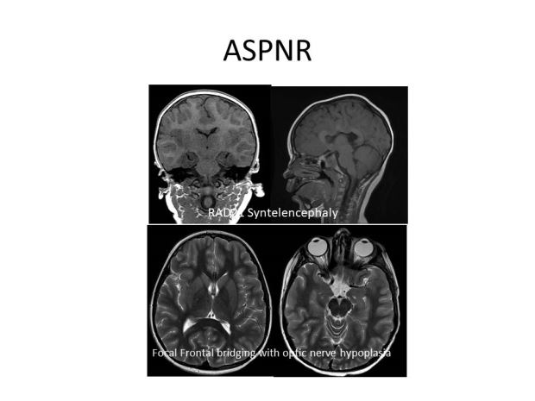

(26) Submission ID#756255
High Incidence of Spontaneous Third Ventriculostomy in Krabbe Disease: A Novel Association
Submitter: Giulio Zuccoli – University of Pittsburgh
Author(s)
Giulio Zuccoli
Pediatric Neuroradiologist
University of Pittsburgh

Aram Kim
University of Pittsburgh

Michele Poe
University of Pittsburgh

Maria Escolar
Founder, Program for the Study of Neurodevelopment in Rare Disorders
University of Pittsburgh

Submission Topic
Brain - Other
Abstract
Purpose: Spontaneous third ventriculostomy (STV) has been reported in children with congenital or acquired stenosis of the aqueduct of Silvius resulting in increased intracranial pressure (ICP). In these patients, a spontaneous perforation of the floor of the third ventricle has been rarely described in the medical literature, as an adaptative response to increased ICP. With the present study, we aim to describe the neuroimaging findings and their clinical associations in patients affected by Krabbe disease and STV. We also aim to discuss the possible causes of spontaneous STV in these patients.
Methods and Materials: A retrospective study of patients with infantile Krabbe disease referred to the Program for the Study of Neurodevelopment in Rare Disorders, under IRB approval. Volumetric Isotropic T1 and T2- 3D MR sequences were screened for: (a) flow void, and (b) perforation/focal defect in the floor third ventricle on mid-sagittal source images (Figure). Both items (a) and (b) were deemed necessary to make the diagnosis of STV. The ventricular system volume was calculated semi-automatically in each patient. Head circumference percentiles were calculated using the Center for Disease Control and Prevention norms for children aged birth to three years. Using standard neurodevelopmental tests we collected signs and symptoms of the disease; growth, mobility, adaptive behavior; receptive and expressive language, motor, and cognitive behavior from the entire cohort.
Results: MRIs of 75 early/late infantile patients with Krabbe disease were evaluated. Among them, 12 cases fulfilling the neuroimaging diagnostic criteria for STV were identified. The head circumference (p< 0.001) as well as the ventricular volume (p< 0.001), were greater in patients affected by STV, as compared to Krabbe patients without STV. Patients with STV had a more delayed development in adaptive (diff=0.2, p< 0.01), gross motor (diff=0.0, p< 0.01), and fine motor behavior (diff=0.1, p< 0.001).
Conclusions: To the best of our knowledge, this is the first report describing STV in Krabbe disease. Furthermore, the positive correlation between STV, increased ventricular size, head circumference, and developmental delay, suggest that Krabbe patients may develop increased ICP. Given the high degree of overlap between symptoms of Krabbe disease and increased ICP, new strategies to monitor increased ICP in Krabbe patients are warranted.
References:
Alonso, A., Taboada, D., Alvarez, J. A., Paramo, C., & Vila, M. (1979). Spontaneous ventriculostomy and ventricular diverticulum. Radiology, 133(3), 651-654.
Alvin, M., Miller, P. E. (2016). Compensated hydrocephalus. Lancet, 387(10036), 2422.

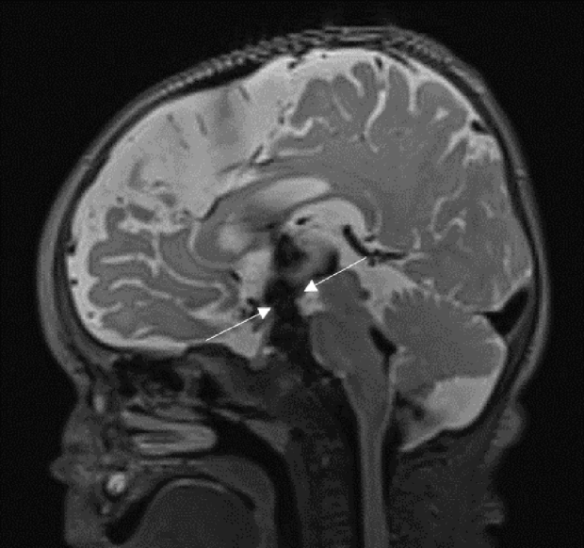

(27) Submission ID#756261
Imaging Characteristics of Pilomyxoid Astrocytomas with Quantitative Description of Diffusion Characteristics and Genetic Signature
Submitter: Mariam Aboian – Yale University
Author(s)
Sandra Abi Fadel
Yale University

Zeynep Erson Omay
Yale University

Armine Darbinyan
Yale University

Asher Marks
Yale University

Richard Bronen
Yale University

Robert Fulbright
Yale University

Mariam Aboian
Assistant Professor
Yale University

Submission Topic
Brain - Tumors
Abstract
Purpose: Pilomyxoid astrocytomas are pediatric brain tumors that are predominantly located in hypothalamus/suprasellar region, third ventricle, and posterior fossa. These are slow growing avidly enhancing tumors that were previously believed to be more clinically aggressive than pilocytic astrocytomas, but recent 2016 WHO classification removed the automatic grade II assignment and recommended further evaluation of behavior of these tumors. Qualitative imaging characteristics have previously been described in these tumors, but there is a need to characterize quantitative imaging features of these tumors. In our study, we describe the MR imaging characteristics of these tumors with emphasis on diffusion weighted imaging and correlation with post-surgical outcomes. Materials and Methods: 7 pediatric patients (age< 21 years give age range) with pathologically proven pilomyxoid astrocytomas and available MRI were identified. ADC (10-3 mm2/s) was measured on Visage Imaging software (Pro Medicus Limited, Visage7). MR imaging characteristics included measurement of size, border, enhancement, T1 and T2 signal characteristics, perfusion (DSC), DTI, and spectroscopy. Study was approved by Institutional Review Board. Results: All 7 tumors were supratentorial, five cases (71%) were suprasellar, 1 was in the frontal white matter and 1 was in the hippocampus. Two of the tumors demonstrated intraventricular extension and hydrocephalus was observed in 3 cases (43%). Majority of the tumors were well circumscribed (86%), T2 hyperintense (86%), and demonstrated avid enhancement (71%), with some tumors demonstrating evidence of central necrosis (57%). Only 2 of the tumors demonstrated homogeneous increased diffusivity on diffusion weighted imaging. Majority of the tumors (71%) had regions of low diffusivity in the background of high diffusivity. Three of the patients with aggressive tumor behavior as evidenced by presence of drop metastases and intraventricular extension, had regions with ADC values below < 1.0x10-6 mm2/s. Among 4 cases with available perfusion imaging, one demonstrated increased perfusion with elevated rCBV. Three cases demonstrated KIAA1549-BRAF fusion, one patient had BRAF V600E mutation and 3 patients tested for BRAFV600E were wildtype. In BRAF wildtype patients, further testing for KIAA1549-BRAF fusion was not performed. Subtotal resection was performed in all of the cases with evidence of tumor recurrence/progression at either 1, 5 or 10 years. Conclusion: Pilomyxoid astrocytomas are positive for KIAA1549-BRAF fusion or BRAFV600E mutation, are avidly enhancing, T2 hyperintense, and demonstrate heterogeneous signal on diffusion weighted imaging with regions of lower ADC values in the background of high diffusivity, which may correlate to presence of drop metastases or intraventricular extension.
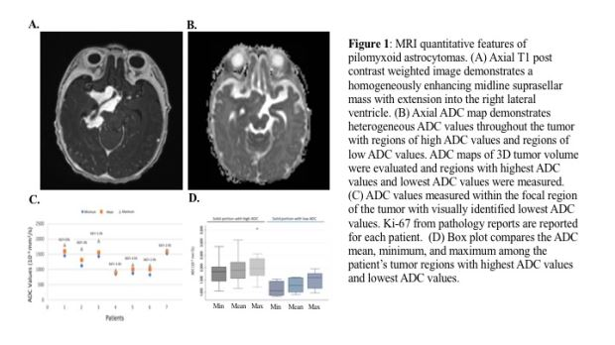
(28) Submission ID#756425
Pediatric Acute Toxic Leukoencephalopathy: Prediction of the Clinical Outcome by FLAIR and Diffusion-weighted Imaging for Various Etiologies
Submitter: kerem ozturk – University of Minnesota
Author(s)
Kerem Ozturk
Neuroradiology Fellow
University of Minnesota

Jeff Rykken
University of Minnesota

Alexander McKinney
Director, Neuroradiology
University of Minnesota

Submission Topic
Brain - Other
Abstract
Purpose: Pediatric acute toxic leukoencephalopathy (PATL) is a clinicoradiologic entity comprised of various etiologies, being characterized by typical neurological deficits and distinctive MRI features. The aim of this study was to determine differences in the DWI and FLAIR appearance of PATL according to various etiologies, and to evaluate their outcomes using both ADC and MRI severity values.
Methods and Materials: Two neuroradiologists retrospectively reviewed the MRI examinations of 25 patients with PATL; inclusion criteria were: MRI < 2 weeks of presentation with both DWI and FLAIR. Two neuroradiologists recorded involved regions on FLAIR and DWI in each, measuring the percentage ADC reduction in visibly affected regions and NAWM by means of ROI ADC measurements, and scored the MR imaging severity/extent. Each patients clinical records were reviewed to determine the cause and clinical outcome. Clinical outcome was scored based on a previously reported scoring system of modified Rankin scale. Logistic regression analysis examined the predictive value of the percentage ADC reduction (%ADCR) and DWI/FLAIR severity scores for clinical outcome. Receiver operating characteristic analysis was applied to obtain percentage ADC reduction cutoff values for the clinical outcome scores.
Results: Of the initial 25 patients, three were excluded because of a nontoxic cause or incomplete examinations. The subgroups of various etiologies of PATL for the remaining 22 consecutive children (11 females, mean age 12.7 years) were the following: methotrexate (n=6), fludarabine (n=4), other chemotherapy (n=6), immunosuppressants for bone-marrow transplantation (n=3), sepsis (n=2), and uremia (n=1). PATL clinically resolved in 77%, with the most severe outcomes in 14% (coma or death, 2/4 deaths being from fludarabine). There was a moderate correlation of the FLAIR severity (r=0.576, p=0.005) and a very strong correlation of DWI severity (r=0.828, p< 0.001) with clinical outcome, although the FLAIR severity correlated stronger in the fludarabine subgroup (r=0.672, p< 0.05), which had the worst outcome. High %ADCR values were associated with adverse outcomes, and lower %ADCR with favorable outcomes (r=0.565, p=0.008). The DWI severity score showed a very high area under the curve (AUC) (0.95) whereas FLAIR severity score (0.86) and %ADCR value (0.74) had relatively modest predictive value.
Conclusion: DWI severity scoring appears highly prognostic, whereas FLAIR severity and %ADC reduction were only moderately prognostic for clinical outcomes in PATL. Overall, fludarabine-related PATL had worse outcomes.

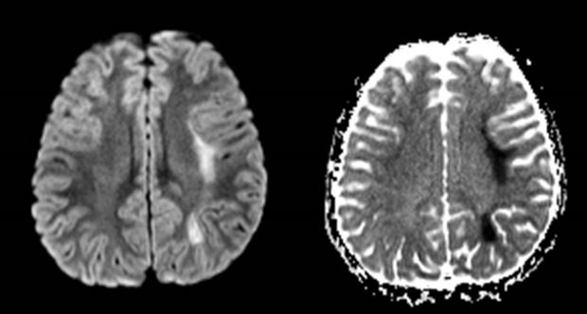

(29) Submission ID#756512
Atlas-based Regional Brain Diffusion MRI Changes Are Present in Children with Sensorineural Hearing Loss
Submitter: Peter Moon – Stanford University School of Medicine
Author(s)
Peter K. Moon
Medical Student
Stanford University School of Medicine

Nathan N. Ng
Medical Student
Stanford University School of Medicine

Jimmy Zheng
Medical Student
Stanford University School of Medicine

Emily McKenna
Stanford University School of Medicine

Katie Shpanskaya, BA
Stanford University School of Medicine

Nathan C. Rowe
University of Calgary

Sarah J. MacEachern
University of Calgary

Alan Cheng
Associate Professor of Otolaryngology - Head and Neck Surgery (Pediatrics)
Stanford University School of Medicine
Nils D. Forkert
University of Calgary

Kristen W. Yeom, MD
Pediatric Neuroradiologist
Stanford University

Submission Topic
Brain - Developmental
Abstract
Purpose
Sensorineural hearing loss (SNHL) is the most prevalent congenital sensory deficit in children.
Early detection and precise etiological description has the potential to improve cochlear implant
outcomes, reduce delay in language development, and confer other significant prognostic
benefits. Identifying cerebral microstructural changes in children with SNHL may have clinical
implications for prognosis prior to cochlear implant. In this study, we hypothesized that there are
diffusion MRI-based microstructural changes of the brain in children with SNHL.
Methods and Materials
Children evaluated for SNHL from 2010-2018 in a single center were retrospectively reviewed
and two study cohorts were formed: 80 SNHL patients and 100 controls. All patients obtained
DWI at 3T. Using atlas-based DWI analysis, we assessed volume of the lateral ventricles, and
both volume and median apparent diffusion coefficient (ADC) in the cerebral cortex, thalamus,
caudate, putamen, globus pallidus, hippocampus, amygdala, nucleus accumbens, brain stem, and
cerebral white matter. Multivariate analysis of covariance was used to test for differences
between controls and patients with SNHL, controlling for gender and age at time of imaging. In
follow-up analyses, SNHL patients were also stratified by unilateral-bilateral hearing loss,
severity, and etiology.
Results
Median ADC of the cortex, thalamus, caudate, hippocampus and brainstem was higher while
brain stem volume was lower in the SNHL cohort compared to control. Unilateral SNHL patients
had increased volume in the cerebral cortex, amygdala, and putamen compared to both control
and bilateral SNHL patients. Bilaterally profound SNHL patients exhibited the same ADC trends
as the overall SNHL cohort when compared to control.
Conclusions
Abnormal diffusion changes were identified in brain regions of children with SNHL prior to
cochlear implant. Diffusion MRI may serve a useful role in characterizing microstructural
changes to the brain in children with SNHL and a potential developmental biomarker prior to
and after therapeutic interventions.

(30) Submission ID#756545
Neuronal Ceroid Lipofuscinosis- clinical Presentation, Age at Diagnosis and MRI Features
Submitter: Asthik Biswas – The Hospital for Sick Children
Author(s)
Asthik Biswas
Clinical Fellow, Neuroradiology
The Hospital for Sick Children

Pradeep Krishnan
The Hospital for Sick Children

Afsaneh Amirabadi
The Hospital for Sick Children

Susan Blaser
The Hospital for Sick Children

Saadet Mercimek-Andrews
The Hospital for Sick Children

Manohar Shroff
The Hospital for Sick Children
Submission Topic
Brain - Other
Abstract
Purpose:
Neuronal ceroid lipofuscinosis are a group of clinically and genetically heterogenous lysosomal storage disorders characterized by intra-neuronal accumulation of auto-fluorescent lipopigments. As a result of storage material in the brain and retina, clinical manifestations include speech, cognitive dysfunction, motor regression, epilepsy, vision loss and early death. At present, 14 different CLN genes (numbered 1-14) are known. Recently, the FDA approved the use of recombinant human proenyzyme of TPP1 for CLN2 disease. Immunomodulatory agents, TFEB activators, phosphodiesterase inhibitors and gene therapy have been developed in animal models with promising results. As most treatment strategies are based on arresting disease progression, early diagnosis is essential for optimal treatment outcomes. The aim of this study is to investigate the clinical and neuroimaging findings of 24 NCL patients at our institution.

Methods and Materials:
After Ethics Board approval, clinical features and neuroimaging results (signal intensity in the thalami, PVWM and DWM, basal ganglia, PLIC, pons and insular regions; supratentorial and infratentorial atrophy) were retrospectively reviewed and analysed.

Results:
There were 24 patients with genetically proven NCL, who underwent 40 brain MRI investigations between 1993 and 2019, with male preponderance (M:F= 15:9). The mean age of disease onset, first brain MRI and age of diagnosis of NCL was 4.70 ± 3.48 years, 6.76 ± 4.49 years and 7.27 ± 4.78 years respectively. Most common symptoms included developmental regression (n=22), impaired speech (n=21) and cognitive decline (n=21). Findings on initial brain MRI included: a) T2/FLAIR hypointensity in the thalami (n=22) b) T2/FLAIR hyperintensity in PVWM and DWM (n=22); c) T2/FLAIR hyperintensity in PLIC (n=22); d) T2/FLAIR hyperintensity in ventral pons (n = 19); e) supratentorial atrophy (n=21; mild (n=10), moderate-severe (n=11)); f) cerebellar atrophy (n=20); and g) T2/FLAIR hyperintensity in the insular/sub-insular region (n=18). Eight out of 9 patients who had follow up neuroimaging showed progressive changes. Imaging could not differentiate subgroups of NCL (CLN1 (n=6), CLN2 (n=5), CLN5 (n=1), CLN6 (n=2), CLN7 (n=6) and CLN8 (n=2), except in CLN3 (n=2) wherein both cases demonstrated subtle findings with slow progression.
Conclusion:
Significant neurodegeneration in the form of T2/FLAIR hypointense thalami; hyperintense white matter, PLIC, insular region and ventral pons; and global atrophy were identified on the initial brain MRI of majority of our NCL patients. The need for early identification of patients with these neuroimaging findings with characteristic history of developmental regression is warranted, especially with new therapeutic advances in the treatment of NCL.

(31) Submission ID#756591
Atlas-based Multi-Parametric Diffusion and Arterial Spin-Labeled Perfusion Changes in Children with Neurofibromatosis Type 1
Submitter: Nathan Ng – Stanford University School of Medicine
Author(s)
Nathan N. Ng
Medical Student
Stanford University School of Medicine

Jimmy Zheng
Medical Student
Stanford University School of Medicine

Lydia Tam
Stanford University

Katie Shpanskaya, BA
Stanford University School of Medicine

Emily McKenna
Stanford University School of Medicine

Kenneth N. Huynh
Medical Student
Arizona College of Osteopathic Medicine

Sarah J. MacEachern
University of Calgary

Cynthia J. Campen
Stanford University School of Medicine

Nils D. Forkert
University of Calgary

Kristen W. Yeom, MD
Pediatric Neuroradiologist
Stanford University

Submission Topic
Brain - Other
Abstract
PURPOSE
Neurofibromatosis type 1 (NF-1) is a multisystem disorder with wide ranging clinical presentations. Children with NF-1 may manifest with macrocephaly, stroke, and cognitive deficit that may impede normal neural development. Here, we applied atlas-based multi-parametric MRI analysis of regional brain to evaluate diffusion, ASL perfusion, and volumetric changes in children with NF-1.
MATERIALS AND METHODS
Children evaluated for NF-1 from 2009 to 2018 in a single center were retrospectively reviewed with 34 patients in the NF-1 group and 100 in the control. All patients underwent DWI at 3T. Children with brain tumors were excluded. Using atlas-based DWI analysis, we assessed volume, median apparent diffusion coefficient (ADC), and cerebral blood flow in the cerebral cortex, thalamus, caudate, putamen, globus pallidus, hippocampus, amygdala, nucleus accumbens, brain stem, and cerebral white matter. We also measured volume of the lateral ventricles. Multivariate analysis of covariance was used to test for differences between controls and NF-1 patients, controlling for gender and age at time of imaging.
RESULTS
Comparing NF-1 to controls, we detected significantly greater volumetric measurements in every brain region; greater median ADC values in all structures except in the putamen and nucleus accumbens; and lower median CBF in the cerebral white matter, globus pallidus, hippocampus, amygdala, and brainstem.
CONCLUSIONS
We demonstrate quantitative measures of microstructural and physiologic changes of the brain in children with NF-1. Atlas-based quantitative MRI brain signatures may serve as useful biomarkers of neural development, cognitive dysfunction, and risks for vasculopathy-related strokes in children with NF-1.

(32) Submission ID#756603
Evaluation of MRI Features for Differentiating Primary Choroid Plexus Tumors in Children
Submitter: Fabricio Goncalves – Children's Hospital of Philadelphia
Author(s)
Fabricio Guimaraes Goncalves, M.D.
Postdoctoral Fellow
The Children's Hospital of Philadelphia

Juan Sebastian Martin-Saavedra
Children's Hospital of Philadelphia

CESAR ALVES
Children Hospital of Philadelphia

Sara Teixeira
The Children's Hospital of Philadelphia

Savvas Andronikou
Childrens Hospital of Philadelphia

Arastoo Vossough
Children's Hospital of Philadelphia
Submission Topic
Brain - Tumors
Abstract
Purpose: To evaluate the diagnostic accuracy of various MRI features for differentiating primary choroid plexus tumors in children.
Methods and Materials: This was a retrospective single-institution review of contrast-enhanced brain MRI scans in 26 pediatric patients with pathologically confirmed supratentorial choroid plexus tumors. Different imaging features were evaluated by three neuroradiologists in consensus, blinded to the final pathology. The features included: precise location, lesion margins, vascularity and vessel distribution, internal architecture, T2 signal, diffusivity, contrast enhancement pattern, overt parenchymal invasion, surrounding vasogenic edema, ventricular septations or entrapment, susceptibility, mass effect, intracranial CSF seeding, and presence of associated arterial territory infarct at time of presentation. Diagnostic accuracy of MRI features was tested for differentiation between papilloma and carcinoma (chi-squared test), and a multivariate diagnostic logistic regression model was also constructed.
Results: The median (interquartile range) age was 1.23 (0.55-3.53) years. Fourteen (54%) were male. There were 18 choroid plexus papillomas and eight choroid plexus carcinomas. 77% of the lesions were located in the lateral ventricles and 27% in the third ventricle. The margins of the tumors were smoothly lobulated in 39% and cauliflower-like in 61%. T2 signal was high in 42% of the cases and intermediate to low in 58%. Restricted diffusion was present in 19% of tumors. Imaging signs of overt invasion was present in 31%. Vasogenic edema surrounding of the adjacent parenchyma was seen in 31%. Susceptibility due to calcium/blood was present in 73% of the cases. Intracranial CSF seeding and metastases were present in 15% of the cases. The most salient independent, statistically significant differentiating imaging features included T2 signal of the mass, the shape of tumor margins (smoothly lobulated vs. cauliflower), presence of overt parenchymal invasion, surrounding edema, and presence of metastases. The multivariate diagnostic feature model showed an area under the curve of 0.93. Optimum cutoff sensitivity and specificity of 100% and 77% was achieved.
Conclusions: A subset of MRI features was helpful in differentiation of choroid plexus papillomas and carcinomas. Diagnostic performance of the multivariate model was very good. This large study shows that a combination of MRI features can be used to develop relatively accurate predictive diagnostic models for differentiating supratentorial primary choroid plexus tumors in children.

(33) Submission ID#756622
Mitochondrial Diseases in Children: Arterial Spin Labeling as a New Approach
Submitter: RAPHAEL LEVY – Hopital Necker
Author(s)
Nathalie Boddaert
Professor , head of department, medical Imaging
Necker hospital

RAPHAEL LEVY
Necker Hospital

Charles-Joris Roux
Necker Hospital

Marlene Rio
Imagine institut

Volodia Dangouloff-ros
Pediatric neuroradiologist
Necker hospital

francis Brunelle
Necker Hospital

agnes rotig
Imagine Institut

Arnold Munnich
Submission Topic
Imaging Techniques
Abstract
Purpose
Arterial spin-labelling (ASL) is a rapid, repeatable, non-invasive and increasingly widely available MR perfusion method for quantitatively measuring cerebral blood flow (CBF) by using arterial water as a freely diffusible tracer. Numerous clinical applications are emerging in children. Here, we wanted to show the interest for the diagnosis of mutated mitochondrial pathologies.
Methods and Materials
4 children (mean age 6.9 years) with mitochondrial disease related to a MT-ATP6 mutation underwent MRI with ASL (GE 1.5-T). Patients 1, 2 and 3 carry the mt.9185 T > C mutation and the 4th patient carries the m.8993T > G mutation. MRI was performed following a Leigh syndrome or epilepsy event suggestive of stroke-like for patients 1, 2 and 4. Patient 3 had no acute neurological symptoms on MRI.
Results
Anatomic MRI shows bilateral striatal abnormalities in 4/4, 3/4 cerebellar atrophy, 0/4 pons abnormality, 2/3 lactate, major T2 cerebellar hypersignal (1/4) and T2 parietal-occipital unilateral hyperintensity (1/4). The MRI ASL shows a hyperperfusion in the striatum (230 ml / min) in patients 1, 2 and 4 with an acute symptom while the perfusion is 90 ml/min/100gr tissue in patient 3 without acute neurological event. The healthy frontal cortex in all the children measures is 75 ml/min/100gr tissue. Cerebellar hyperperfusion (200 ml /min) and occipito-parietal hyperperfusion (292 ml / min) were found in the both stroke-like cases.
Conclusion
MRI ASL showed a major hyperperfusion in Leigh syndromes with acute neurological signs and in stroke-like. This underlines the interest of the ASL in this pathology, which also allows to differentiate stroke from stroke-like (ASL being decreased in classical strokes). We suggest systematic ASL in acute neurological deficits.

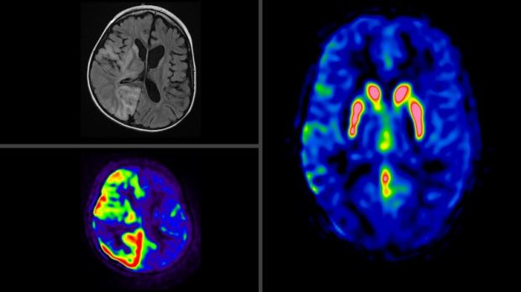

(34) Submission ID#756669
Utility of Brain Segmentation in Children as a Predictor for Single Seizure versus Epilepsy: A Retrospective Analysis
Submitter: Andres Su – Emory University Hospital
Author(s)
Andres W. Su, MD
Assistant Professor
Department of Radiology and Imaging Sciences, Emory University School of Medicine

Omar N. Kallas, MD
Resident
Department of Radiology and Imaging Sciences, Emory University School of Medicine

Binjian Sun, PhD
Image Processing Scientist
Childrens Healthcare of Atlanta

Judith A. Gadde, DO, MBA
Assistant Professor
Department of Radiology and Imaging Sciences, Emory University School of Medicine

Submission Topic
Brain - Epilepsy
Abstract
Purpose
In 2015, 1.2% of the United States population was living with active epilepsy, including approximately 470,000 children. The significant morbidity and mortality of untreated epilepsy makes early recognition and proper treatment critical. Conventional brain MRI plays a valuable role in the search for epileptogenic lesions but does not reliably predict progression from a first-time seizure to an epilepsy disorder. We hypothesize that patients who progress to epilepsy can be distinguished from those with single seizures by changes in brain subfield volumes.
Methods and Materials
Two groups of patients ages 8-18, 30 with single unprovoked seizures and 54 with history of multiple seizures and diagnosed epilepsy, were identified through an imaging report database search and chart review. All patients underwent brain MRI according to the pediatric seizure protocol at our institution. Volumetric 3D T1-weighted sequences were segmented using the FreeSurfer software package to provide volumes for 10 regions of interest including the hippocampus, amygdala, and nucleus accumbens. Comparing the two groups, we assessed differences in left and right subfield volumes normalized for total intracranial volume, and in the left-right asymmetry index for each subfield using the Wilcoxon signed-rank test.
Results
The normalized volume of the amygdala was significantly greater in patients with multiple seizures than those with single seizures (0.11 versus 0.1 on the left, p=0.043; 0.12 versus 0.11 on the right, p=0.022). There was no significant difference in normalized volume for the remaining subfields, nor in the asymmetry index for any of the subfields.
Conclusions
The normalized volume of the amygdala is increased in our cohort of pediatric patients with diagnosed epilepsy compared to those with single seizures. Amygdala enlargement has been reported in association with medial temporal lobe epilepsy in adult patients. Evaluation of larger pediatric patient cohorts is needed to confirm our finding and to assess its utility for predicting progression from a first-time seizure to epilepsy disorder.
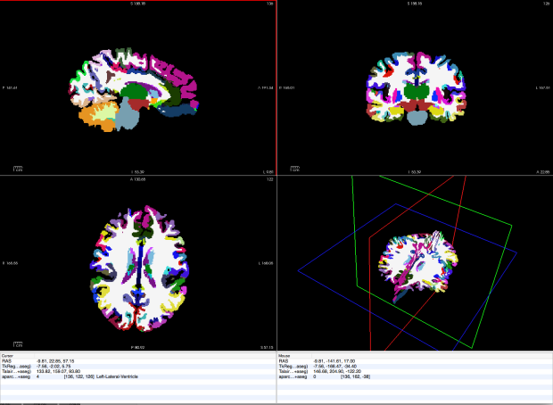
(35) Submission ID#756897
A Pattern Approach to MR Imaging in Urea Cycle Disorders: Predicting Lesion Distribution Using Diffusion-weighted and FLAIR MR Imaging
Submitter: kerem ozturk – University of Minnesota
Author(s)
Kerem Ozturk
Neuroradiology Fellow
University of Minnesota

David Nascene, MD
University of Minnesota Medical School

Alexander McKinney
Director, Neuroradiology
University of Minnesota
Submission Topic
Brain - Other
Abstract
Purpose: The precise lesion distribution of diffusion restriction and high FLAIR signal abnormalities in urea cycle disorders (UCDs) are not fully recognized. To determine the contribution of MRI to the diagnosis of UCD and to assess characteristic regions of involvement utilizing DWI and FLAIR images.
Methods and Materials: Ten consecutive patients (3 females, mean age 14.9 years) were included in our study who had undergone MRI and DWI analysis and were diagnosed with UCD via laboratory or genetic studies. The topographic distributions of the DWI and FLAIR abnormalities of the cortex, deep gray matter, and white matter structures were evaluated, with ADC measurements. Associations between the lesion locations on each MR sequence were examined utilizing a binomial test. MR imaging findings were compared in relation to the UCD subtypes.
Results: The UCD cohort (n=10) of patients involved four ornithine transcarbamoylase deficiencies (OTCD), four with argininosuccinic aciduria (ASA), one carbomoylphosphate synthetase deficiency (CPSD), and one citrullinemia type 1 (CT1). On FLAIR and DWI respectively, there were abnormalities in the basal ganglia (90%, 40%), thalami (10%, 0%), cerebellum (10%, 0%), brainstem (0%, 20%), centrum semiovale (10%, 10%), cerebral peduncle (0%, 10%), frontoparietal cortex (60%, 40%), and insular cortex (20%, 20%). Although DWI revealed hyperintensity for most lesions, reduced ADC was found within the frontoparietal cortex (n=4), insular cortex (n=2), basal ganglia (n=1), centrum semiovale (n=1) and cerebral peduncle (n=1). The most frequently involved region was the basal ganglia on FLAIR (9/10, 90%), where the frontoparietal cortex was involved concurrently with the basal ganglia more frequently in OTCD. Involvement of white matter structures was only observed in one patient, who had CT1.
Conclusions: UCDs have characteristic regions of involvement on FLAIR and DWI. Most correspond to areas of vasogenic edema, while a minority represents cytotoxic edema.

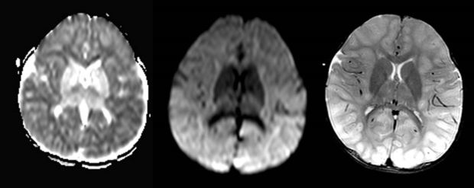

(36) Submission ID#756906
Myelination Timeline of the Pediatric Spinal Cord
Submitter: ELIZABETH WEIDMAN – Weill Cornell Medicine - NewYork Presbyterian
Author(s)
Elizabeth K. Weidman, MD
Assistant Professor of Radiology
Weill Cornell Medicine - New York Presbyterian Hospital

Arastoo Vossough
Children's Hospital of Philadelphia
Submission Topic
Spine
Abstract
Purpose
Unmyelinated normal white matter tracts in the pediatric spinal cord have T2-hyperintense signal on MRI and may mimic spinal cord disease. Autopsy studies have described incomplete myelination of spinal cord white matter tracts in early childhood, however the timeline of myelination of the spinal cord is not well known on imaging. The purpose of this study is to retrospectively evaluate the maturation timeline of spinal cord myelination on MRI in order to serve as a baseline for image interpretation.
Materials and Methods
Axial T2-weighted images of the cervical and thoracic spine acquired on 1.5 and 3.0 Tesla MRI between 1/1/2002 3/27/2019 in children age 0-2 years were retrospectively reviewed for presence of longitudinal T2-hyperintense signal in the spinal cord. Images were acquired as part of routine clinical care at a tertiary care childrens hospital. Summary of medical records was reviewed for presence of known confounding pathology in the brain or spine. Cord signal was interpreted as normal in the clinical report by a subspecialty-trained pediatric neuroradiologist for all patients included in this study.
Results
435 MRI exams from 409 patients were retrospectively reviewed. 190 studies were included in analysis and 245 were excluded (due to motion-degraded axial T2, confounding pathology including white matter disease, tumor, infarct or parenchymal injury on spine or concurrent brain MRI). Longitudinal T2-hyperintense signal in the lateral cord was seen in all (15/15) subjects 0-1 month of age, and was not seen in subjects 21-24 months of age (0/15). By age group, T2 hyperintense signal was seen in 76.7% (33/43) of subjects age 0-2 months, 24.3% (9/37) age 3-5 months, 15.0% (3/20) age 6-8 months, 26.7% (4/15) age 9-11 months, 23.8% (5/21) age 12-14 months, 23.8% (5/21) age 15-17 months, 5.6% (1/18) age 18-20 months, and 0.0% (0/15) age 21-24 months.
Conclusion
Characteristic longitudinal T2-hyperintensity in the spinal cord is commonly seen in infants and should not be mistaken for pathology, and was not seen in children beyond 21 months of age in our study, likely reflecting progression of myelination. Future studies including larger cohorts of young children without and with spinal cord pathology are warranted.
References
Brody BA, et al. Sequence of central nervous system myelination in human infancy. I. An autopsy study of myelination. J Neuropathol Exp Neurol. 1987;46(3):283-301.
Hedley-Whyte ET, Gilles FH. Observations on myelination of human spinal cord and some effects of parturitonal transection. J Neuropathol Exp Neurol. 1974;33(3):436-445.
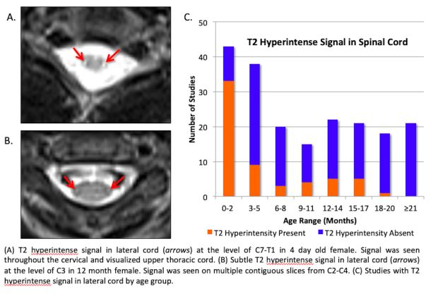

(37) Submission ID#756914
Neuro Imaging Findings of Infants Born at Less Than 24 Weeks
Submitter: Maria Dien Esquivel – CHEO
Author(s)
Maria F. Dien-Esquivel
CHEO, Medical Imaging Department, University of Ottawa

Laura Acosta-Izquierdo
CHEO, Medical Imaging Department, University of Ottawa

Elka Miller
CHEO, Medical Imaging Department, University of Ottawa

Emanuela Ferreti
CHEO, Department of Pediatrics, University of Ottawa

Claudia Martinez-Rios
CHEO, Medical Imaging Department, University of Ottawa

Submission Topic
Brain - Other
Abstract
Purpose: Advances in neonatal intensive care units have led to substantial improvement in survival of extremely low gestational age (ELGA) infants (younger than 24 weeks GA), who are particularly susceptible to several complications due to prematurity. In the brain these include white matter injury, ischemia, edema and bleed. Such risks increase with lower birth weight and lower gestational age. Due to their fragility and clinical instability, these neonates are mainly assessed at bedside with brain ultrasound (US) in their first weeks of life, which helps identifying complications and to guide further care. Eventually magnetic resonance (MR) imaging is performed to assess the integrity of the neonatal brain. There is limited literature on the postnatal imaging findings of ELGA infants. The purpose of this study is to review the neuroimaging characteristics of ELGA infants who underwent postnatal US and MR imaging to document which type of CNS complications and their short and long term clinical outcomes.
Material and Methods: This is a retrospective study REB approved -at a tertiary care pediatric center of all extremely low gestational age infants (< 24 weeks) admitted to the neonatal intensive care unit between January 1, 2010 and September 10, 2019, who had neuroimaging (brain US and MR imaging) as part of their diagnostic work-up. Imaging findings, complications and clinical outcomes were recorded.
Results: 42 ELGA infants were identified. Five underwent US and MRI and were included. Summary of neuroimaging findings in this small subgroup included for US: intraparenchymal hemorrhages (n = 2), cerebellar hemorrhage (n = 1), unilateral grade 3 intraventricular hemorrhage (n = 1), bilateral grade 2 intraventricular hemorrhages (n = 1), bilateral subependymal hemorrhages (n = 1), periventricular cystic leukomalacia (n = 1), porencephalic cyst (n = 1), ventricular enlargement (n=4). MR imaging findings included: white matter volume loss (n =3), periventricular white matter change (n = 2), distortion/asymmetry (n = 2), ventricular blooming artifacts (n = 4), ventricular dilatation (n = 4), hypoplastic optic nerves (n = 2). Clinical outcome was: developmental delay (n = 2), appropriate development (n = 2). One lost to follow up.
Conclusions: We summarize the spectrum of CNS abnormalities seen in ELGA infants, emphasizing the use of brain US for prompt identification of intracranial complications. Since we now care for these extremely premature infants, an appropriate understanding of their normal and abnormal imaging findings is paramount.
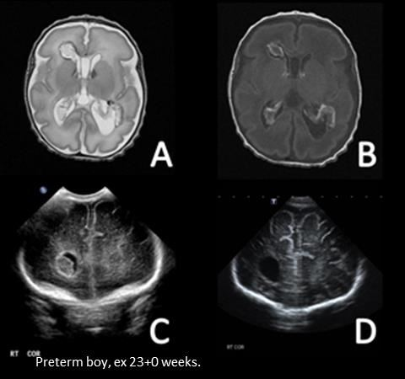
(38) Submission ID#755996
Use of Fast EPI MRI Sequences for the Acute Evaluation of Pediatric Patients in the Emergency Department
Submission Type: Scientific Paper (Oral Presentation)
Submission Status: Complete / Locked
Submitter: Sarah Moum – Massachusetts General Hospital

Author(s)
Sarah J. Moum
Massachusetts General Hospital

Sandra Rincon
Massachusetts General Hospital

Ramon Gilberto Gonzalez
Massachusetts General Hospital

Paul Caruso
Massachusetts General Hospital

Karen Buch
Massachusetts General Hospital

Submission Topic
Imaging Techniques
Previously Presented
Abstract
Purpose:
Imaging children in the emergency setting has many diagnostic and logistic challenges. Neuroradiologists are often weighing fast scan times with sequence selection for answering clinical questions. Fast MRI techniques have recently emerged to help obtain diagnostic brain MRI sequences without the need for sedation in pediatric patients. The purpose of this study was to investigate the utility of fast EPI MRI for the evaluation of pediatric patients presenting to our institutions emergency department.
Methods and Materials:
This was a retrospective study with IRB approval. A total of 30 patients presenting to our emergency department from October 2018 to August 2019 received a fast EPI MRI exam, which included axial diffusion, axial susceptibility, axial FLAIR, axial T1, and axial T2 sequences. All imaging was performed on a 1.5T GE scanner in 90 seconds. All patients also concurrently underwent either a quick brain triplanar T2 SSFSE (n=2) or conventional diagnostic MRI brain exam (n=28). Two neuroradiologists, K.B. and S.J.M., independently reviewed the fast EPI MRI brain exams, triplanar T2 SSFSE MRI brain exams, and conventional diagnostic MRI brain exams, specifically evaluating for acute processes (i.e. infarction, intracranial hemorrhage, mass lesion, hydrocephalus, midline shift, and pathologic fluid collection).
Results:
Of the 30 patients, 17 males and 13 females were identified with an average age of 13.9 years (range: 3-18 years). All of the fast EPI MRI brain exams (n=30) were concordant with the conventional MRI brain exams for the evaluation of infarction, intracranial hemorrhage, mass lesion, hydrocephalus, midline shift, and pathologic fluid collection. No acute findings were missed on fast EPI sequences.
Conclusions:
This pilot data suggests that fast MRI using a fast EPI technique may be feasible for the imaging evaluation of pediatric patients in the emergency setting without the need for sedation or radiation.


